**National Center for Biotechnology Information (NCBI)**

1.Download the gene sequence and mRNA sequence of Leptin and Leptin Receptor gene of Human, Mouse and Rat, Cattle and Pig. Save it in a separate folder and name it properly.

i. What is the chromosomal location of (i) Leptin and (ii) Leptin Receptor in these organisms?

ii. Compare the length of the gene sequences of (i) Leptin and (ii) Leptin Receptor in these organisms?

iii. Write the accession number of (i) Leptin and (ii) Leptin Receptor in these organisms?

iv. How many exons do you find in the gene sequence of (i) Leptin and (ii) Leptin Receptor in these organisms?

v. Write the start and end position of the exons in the gene sequence of (i) Leptin and (ii) Leptin Receptor in these organisms?

vi. Is there any publication related to these sequences? If so, quote it.

Answer:

NCBI Home Page

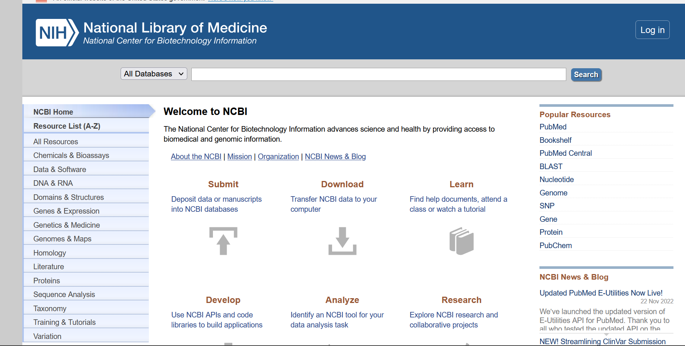

Organism: Human

|  |  |  |
| --- | --- | --- |
|  | Leptin | Leptin Receptor |
| Chromosomal Location | Chromosome 7  NC_000007.14 (128241278..128257629) | Chromosome 1  NC_000001.11 (65420652..65641559) |
| Length of Gene Sequence | 16352 bp | 220908 bp |
| Accession Number | NC_000007 | NC_000001 |
| Number of Exons | 3 | 24 |
| Start and End positions of Exons |  | complement(155303..157153)  complement(157607..157848) |
| Publications | REFERENCE - 2 (bases 1 to 16352)  AUTHORS - Hillier,L.W., Fulton,R.S., Fulton,L.A., Graves,T.A., Pepin,K.H., Wagner-McPherson,C., Layman,D., Maas,J., Jaeger,S., Walker,R.  TITLE - The DNA sequence of human chromosome 7  JOURNAL - Nature 424 (6945), 157-164 (2003)  PUBMED - 12853948 | REFERENCE - 1 (bases 1 to 220908)  AUTHORS - Gregory,S.G., Barlow,K.F.,McLay,K.E., Kaul,R., Swarbreck,D.,Dunham,A., Scott,C.E., Howe,K.L.,Woodfine,K.,Spencer,C.C.,  Jones,M.C., Gillson,C., Searle,S.,  TITLE - The DNA sequence and biological annotation of human chromosome 1  JOURNAL - Nature 441 (7091), 315-321 (2006)  PUBMED - 16710414 |

Hits Page

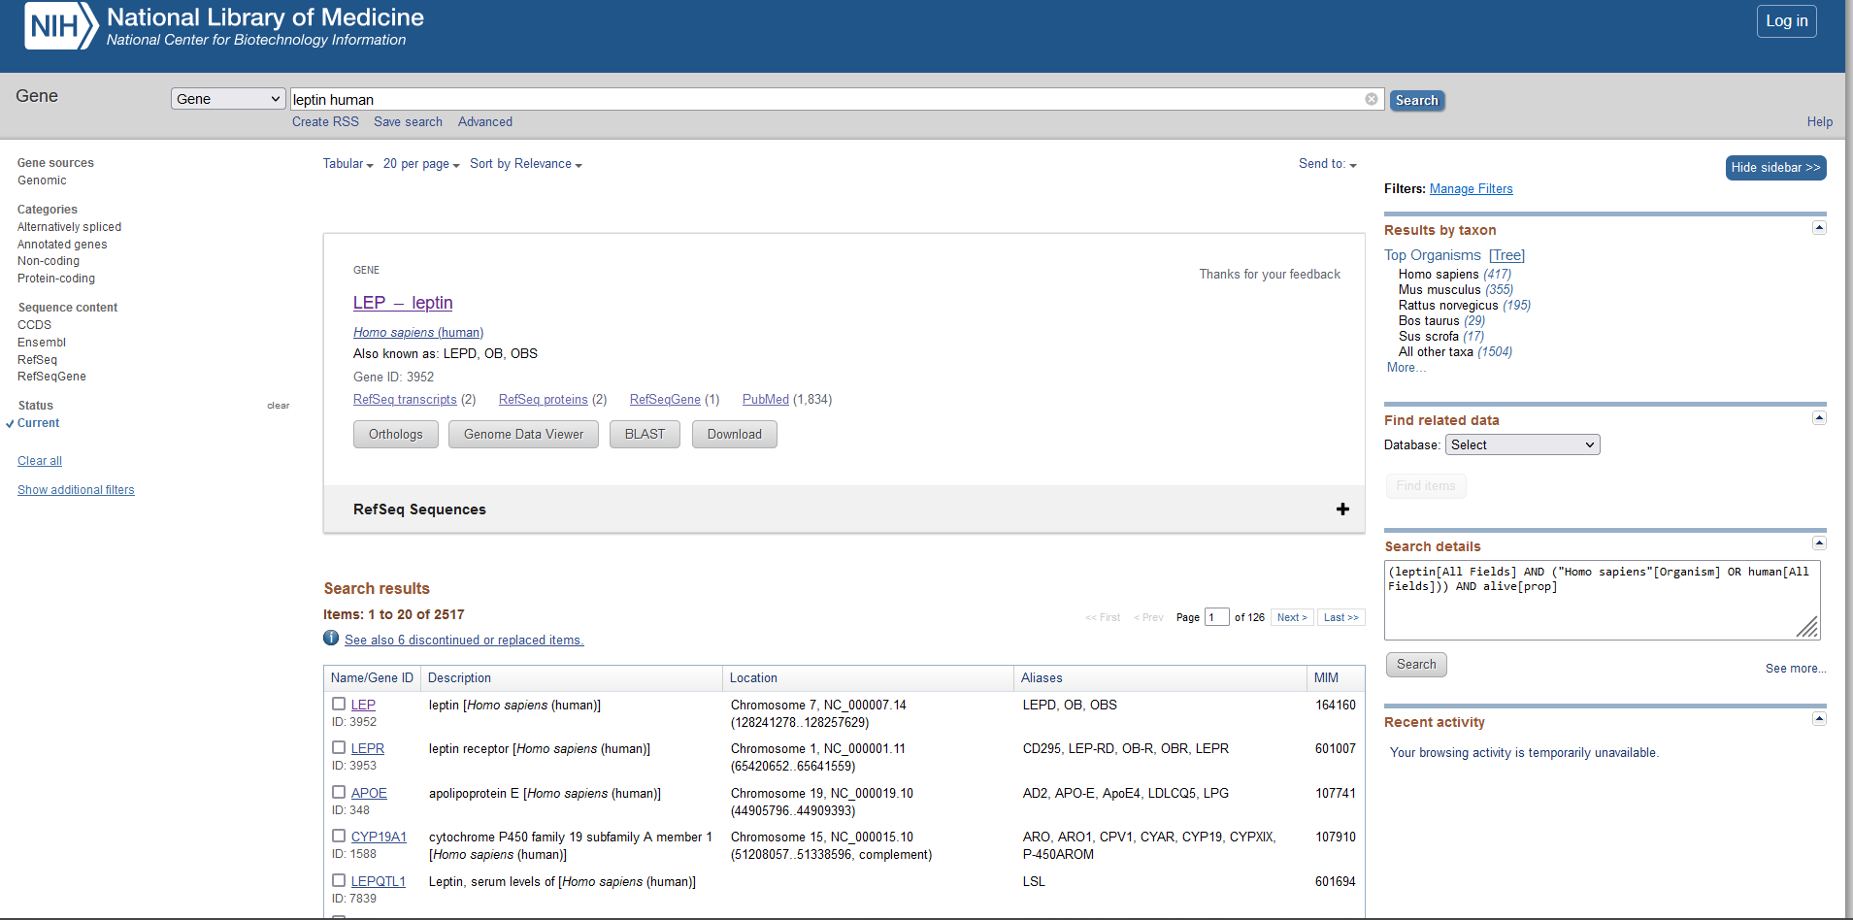

Chromosome location – Leptin Human

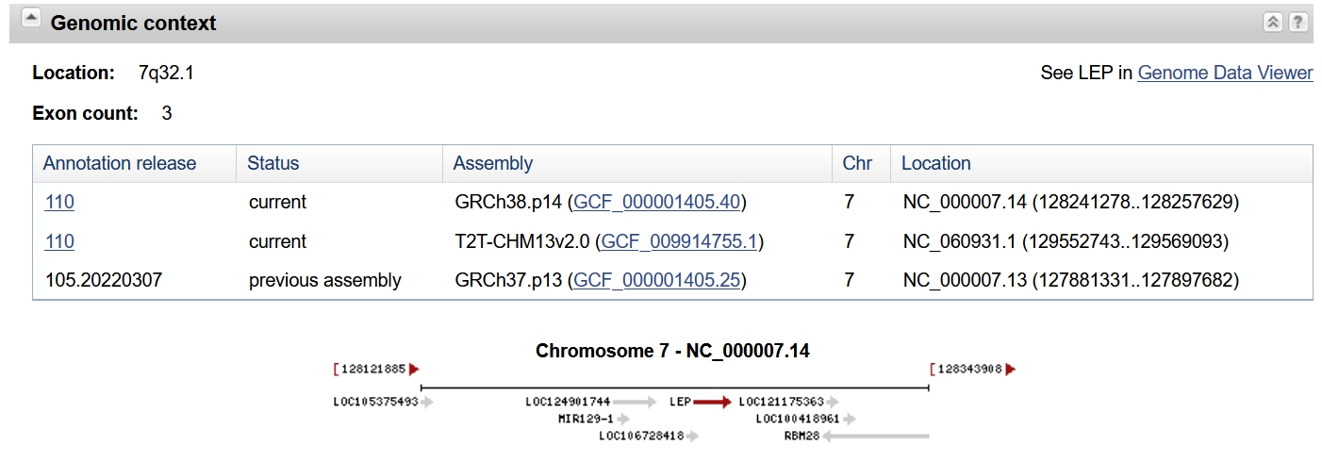

Genbank

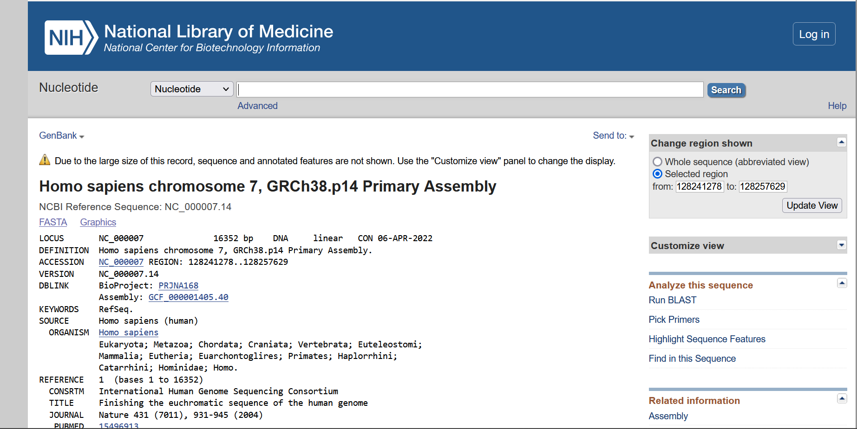

Gene Sequence – Leptin Human

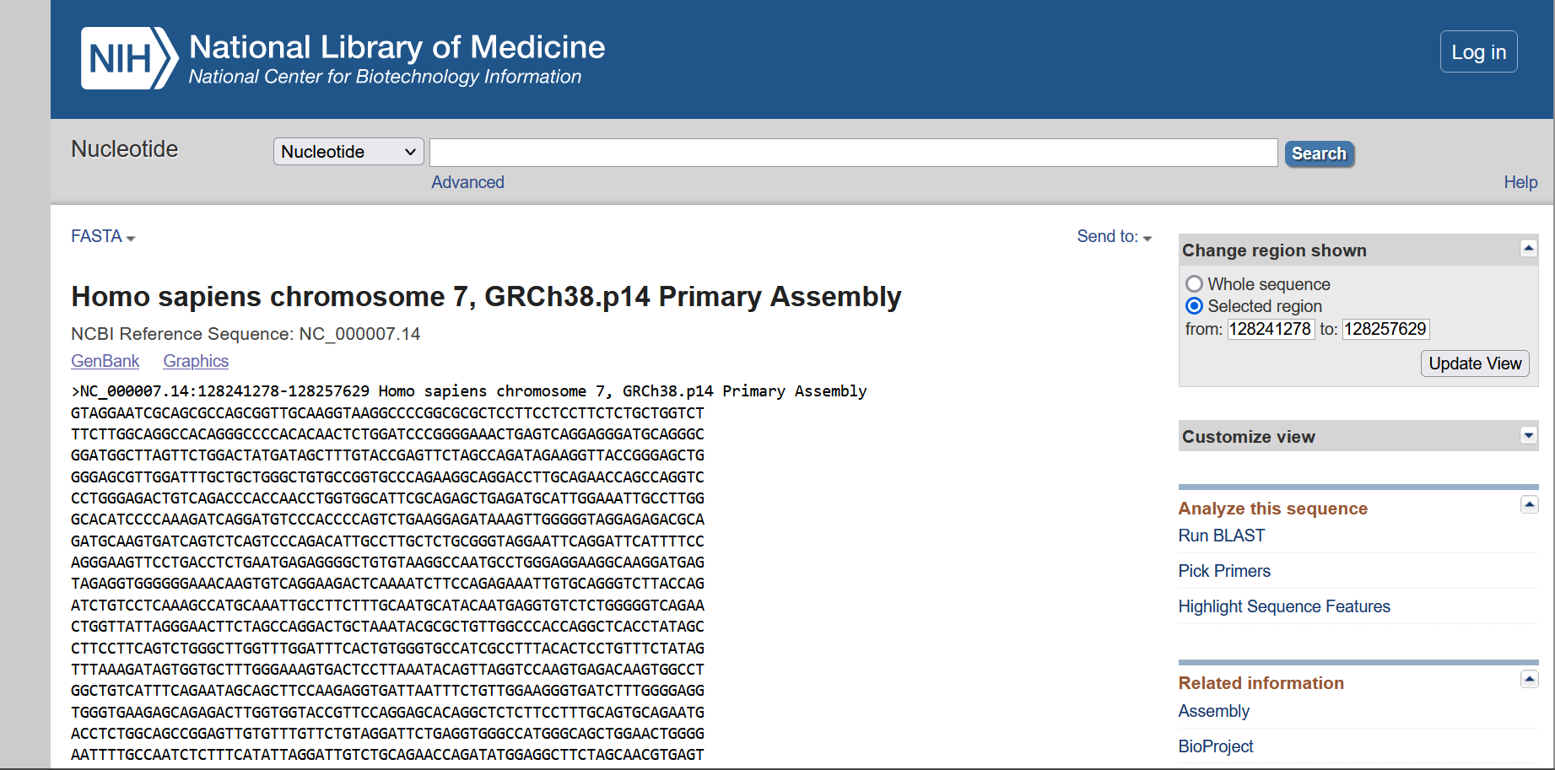

mRNA Sequence – Leptin Human

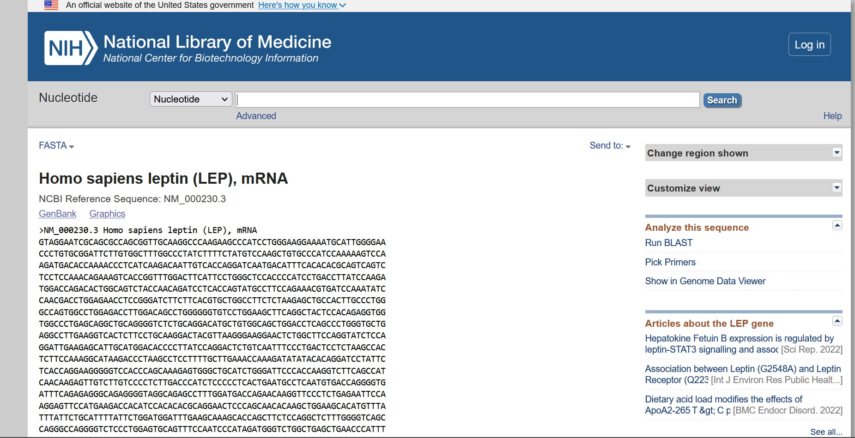

Chromosome location – Leptin receptor Human

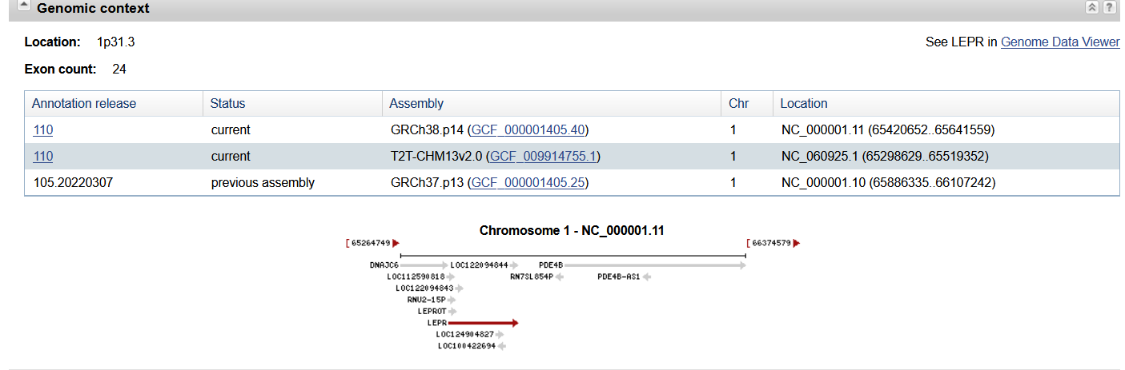

Genbank

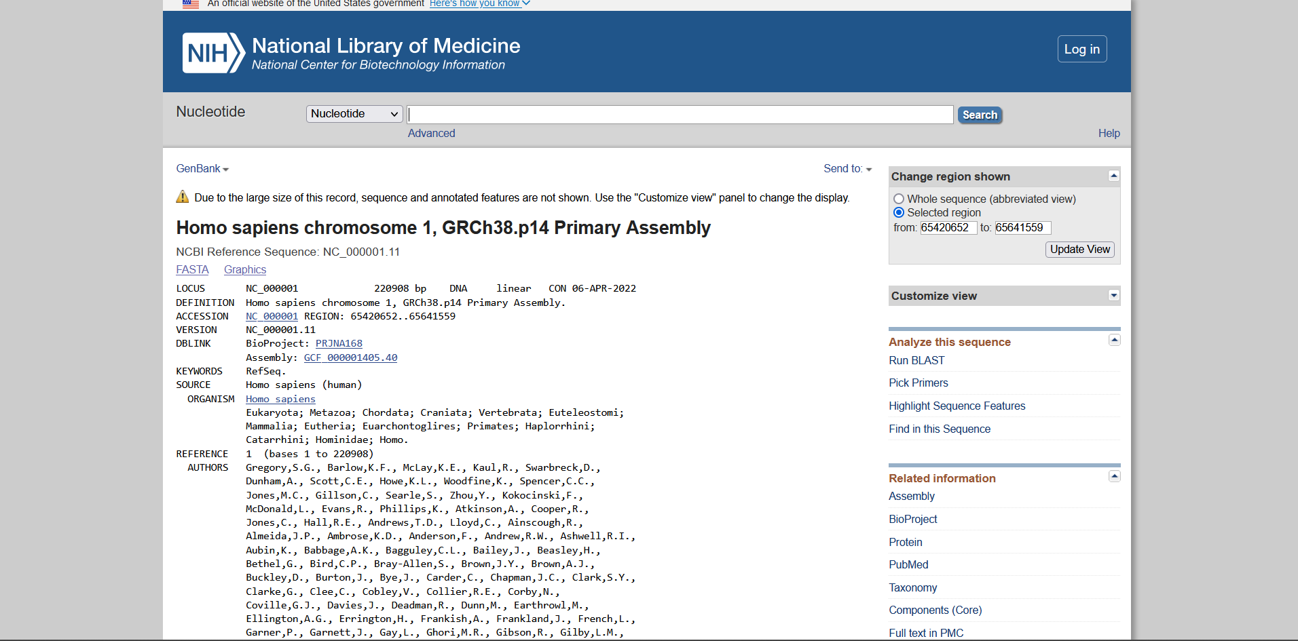

Gene Sequence – Leptin receptor Human

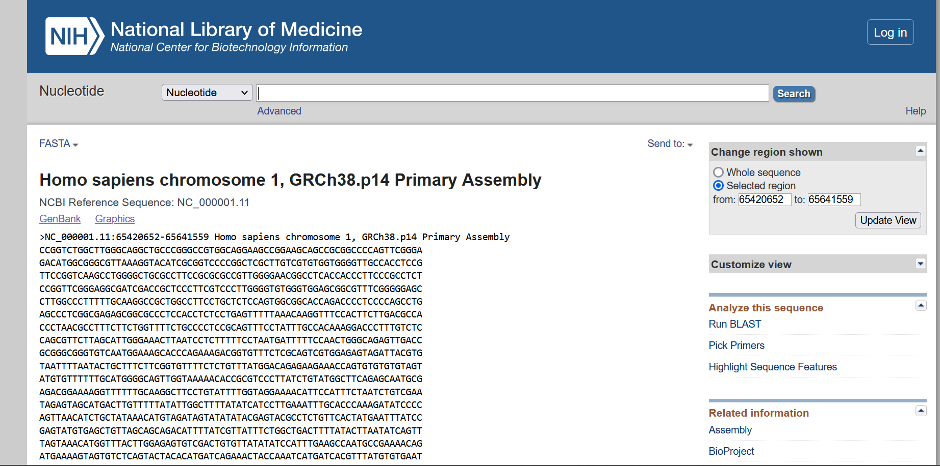

mRNA Sequence – Leptin receptor Human

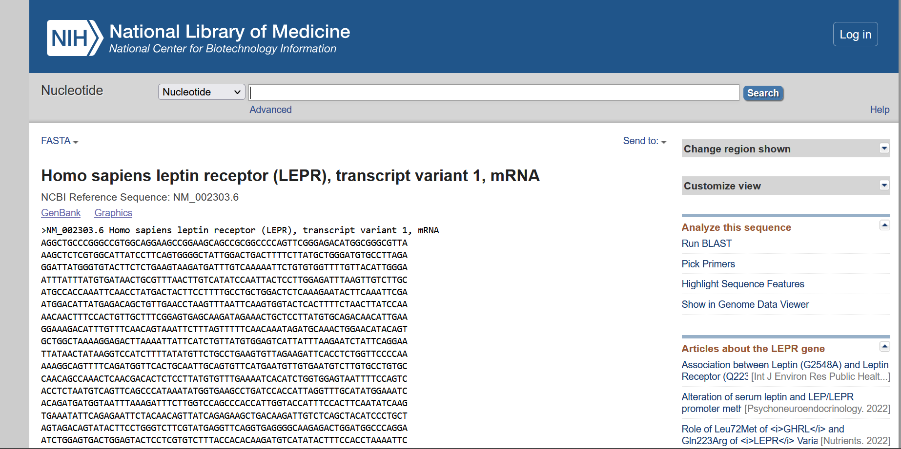

Organism: Mouse

|  |  |  |
| --- | --- | --- |
|  | Leptin | Leptin Receptor |
| Chromosomal Location | Chromosome 6  NC_000072.7 (29060220..29073875) | Chromosome 4  NC_000070.7 (101574393..101676375) |
| Length of Gene Sequence | 13656 bp | 101983 bp |
| Accession Number | NC_000072 | NC_000070 |
| Number of Exons | 3 | 21 |
| Start and End positions of Exons |  |  |
| Publications | REFERENCE - 1 (bases 1 to 13656)  AUTHORS - Church,D.M., Schneider,V.A., Graves,T., Auger,K., Cunningham,F.,  Bouk,N., Chen,H.C., Agarwala,R., McLaren,W.M., Ritchie,G.R., Albracht,D., Kremitzki,M., Rock,S., Kotkiewicz,H., Kremitzki,C.  TITLE - Modernizing reference genome assemblies  JOURNAL - PLoS Biol. 9 (7), e1001091 (2011)  PUBMED – 21750661 | REFERENCE - 1 (bases 1 to 101983)  AUTHORS - Church,D.M., Schneider,V.A., Graves,T., Auger,K., Cunningham,F.,Bouk,N., Chen,H.C., Agarwala,R., McLaren,W.M., Ritchie,G.R.,Albracht,D., Kremitzki,M., Rock,S., Kotkiewicz,H., Kremitzki,C.  TITLE - Modernizing reference genome assemblies  JOURNAL - PLoS Biol. 9 (7), e1001091 (2011)  PUBMED - 21750661 |

Hits page

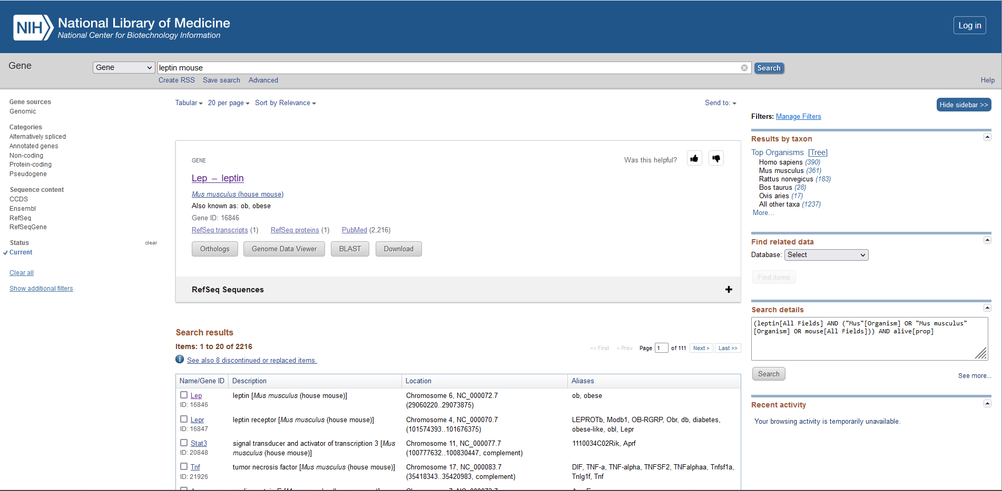

Chromosome location – Leptin Mouse

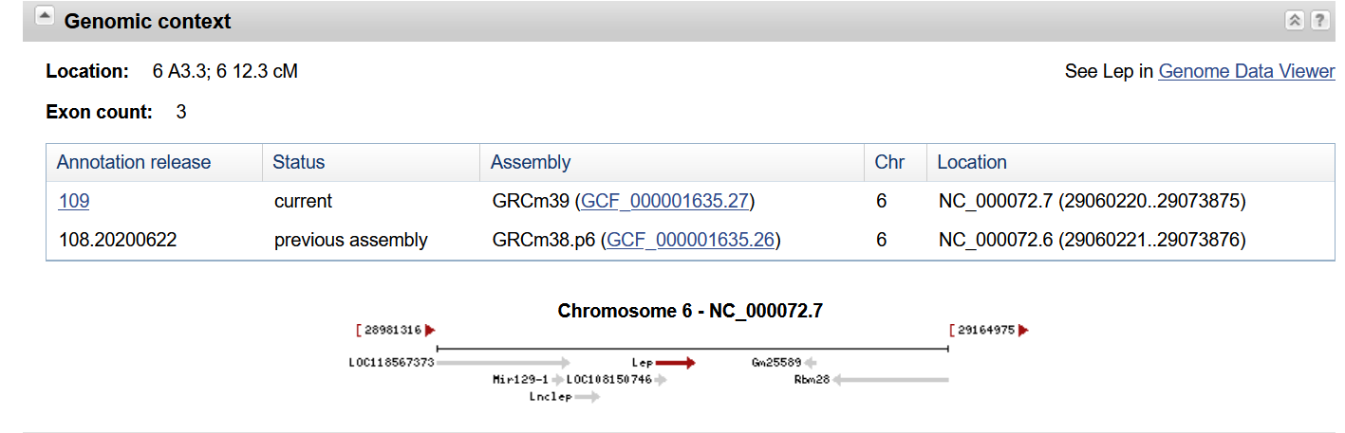

Genbank

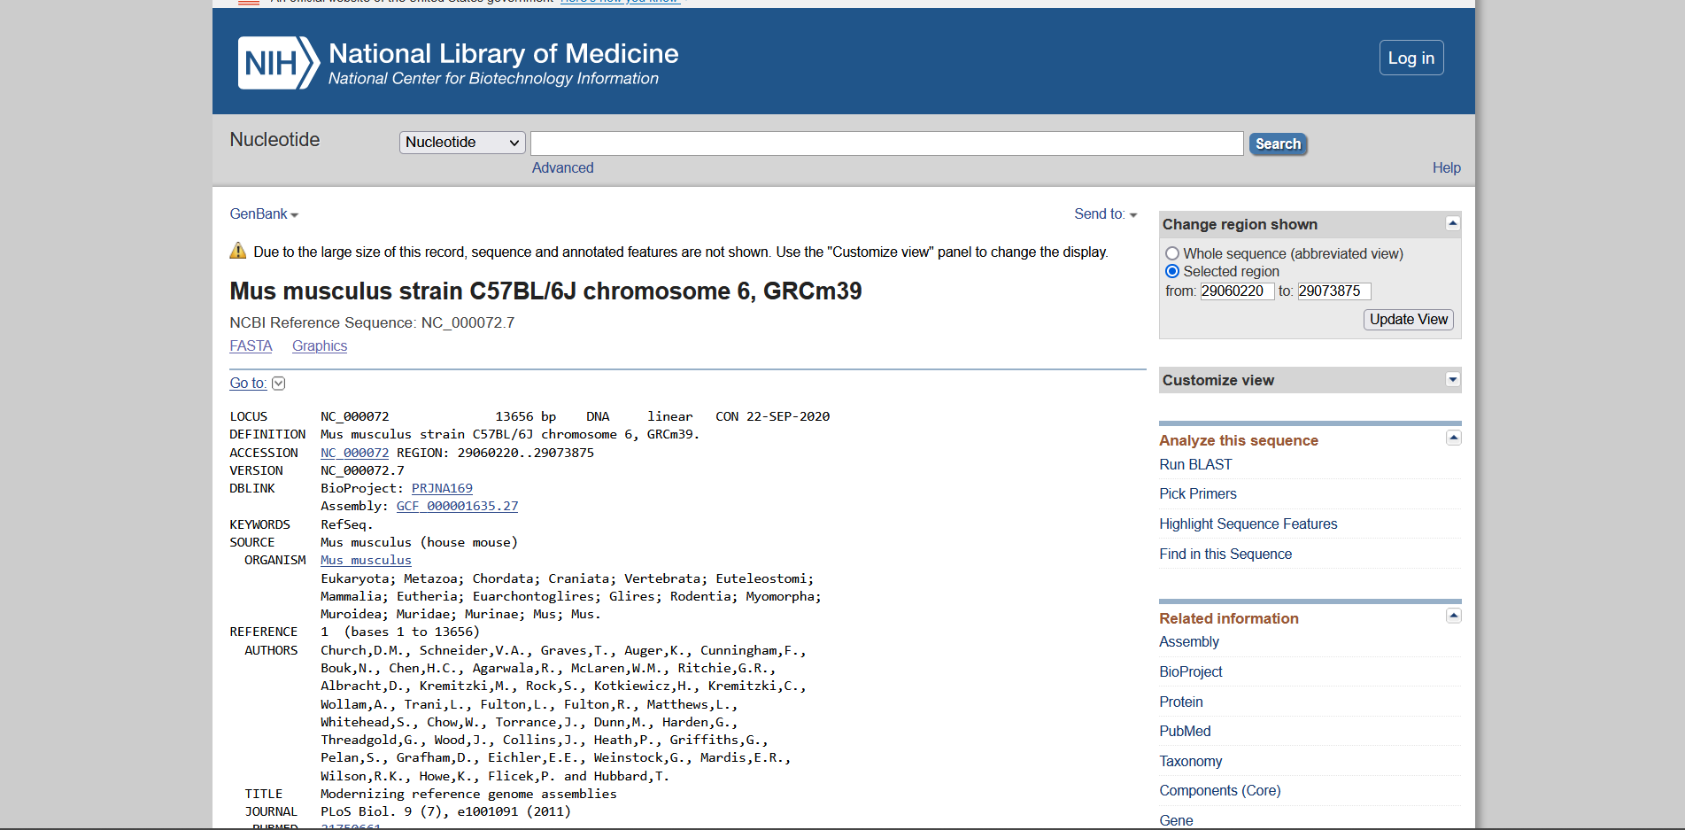

Gene Sequence – Leptin Mouse

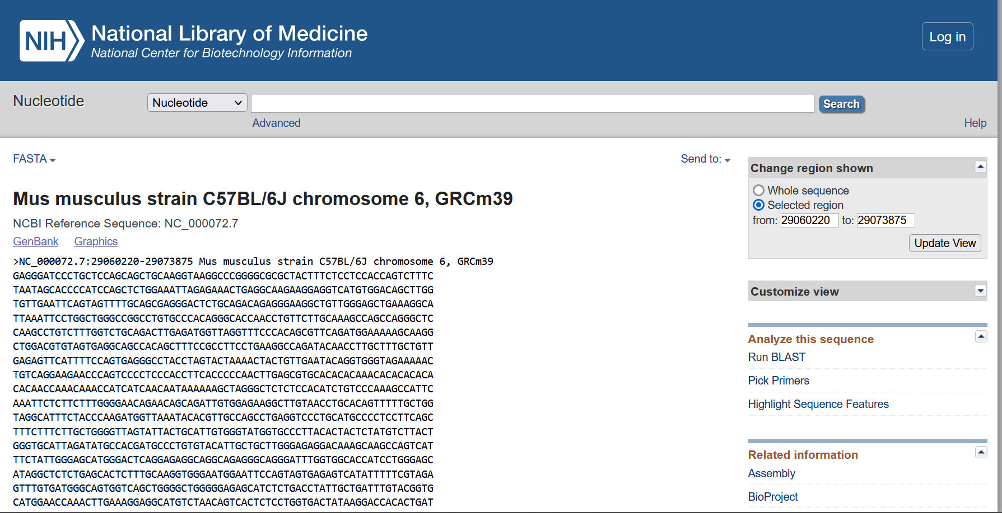

mRNA Sequence - Leptin Mouse

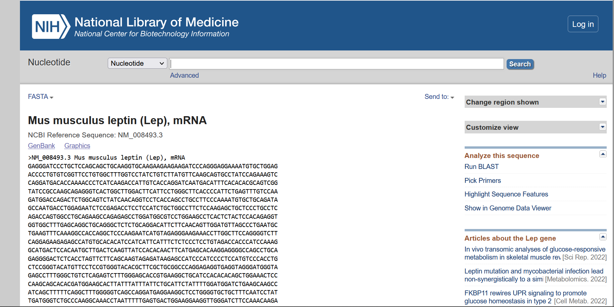

Chromosome location – Leptin receptor Mouse

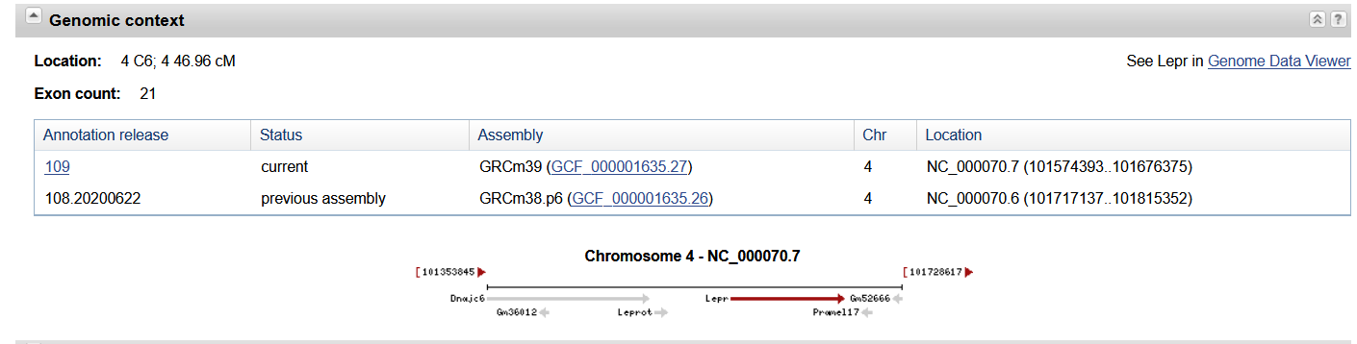

Genbank

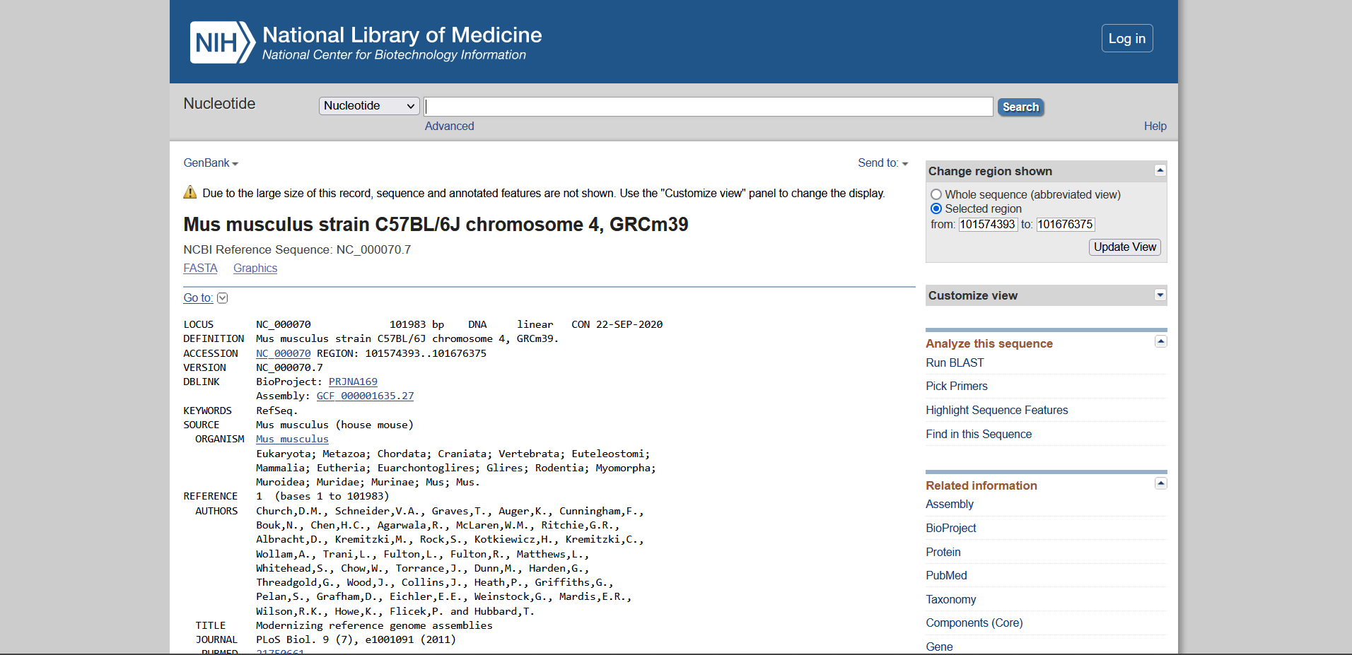

Gene Sequence – Leptin receptor Mouse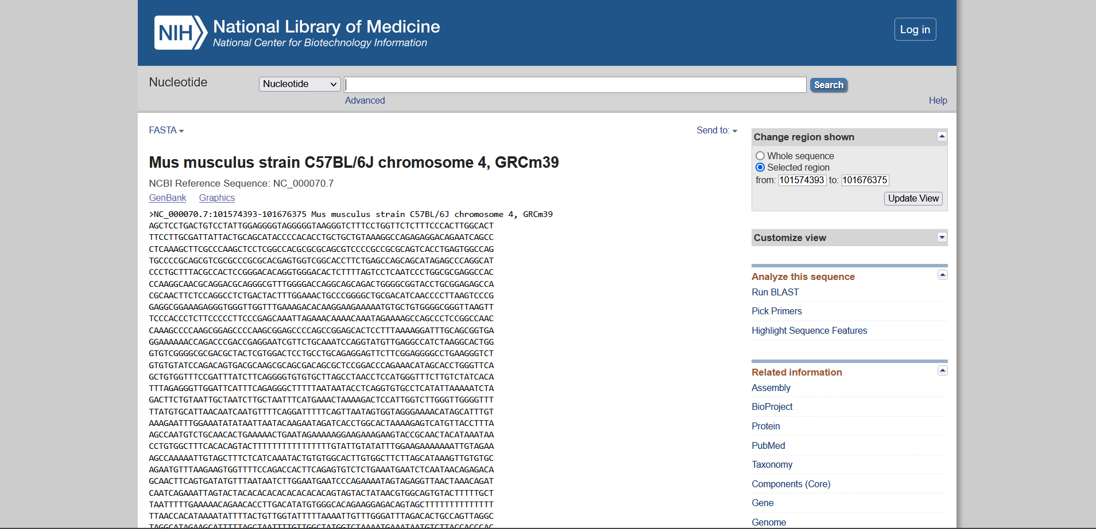

mRNA Sequence - Leptin receptor Mouse

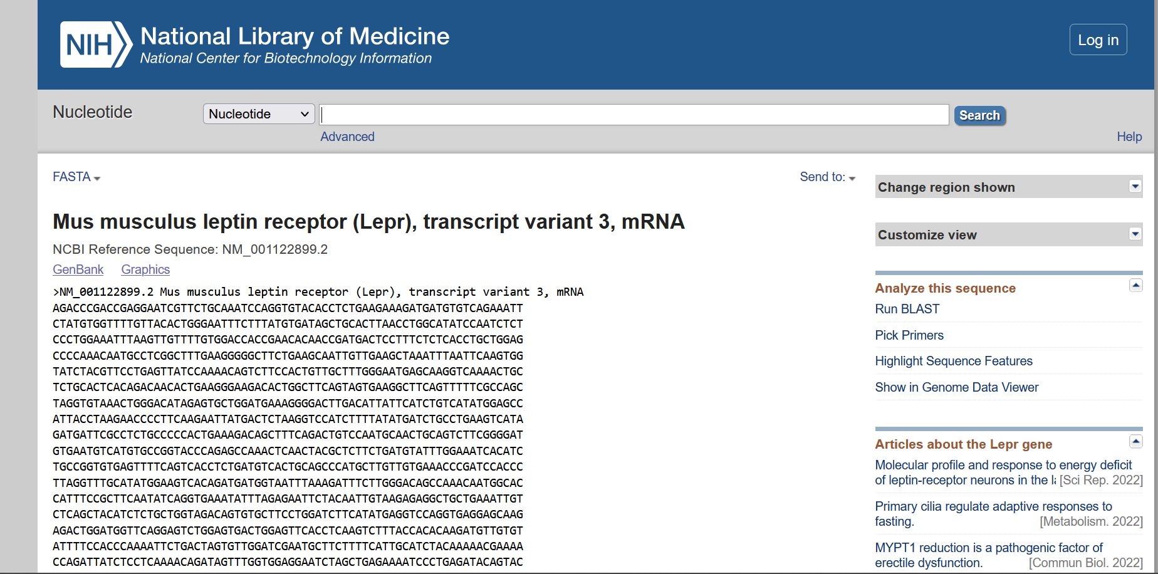

Organism: Rat

|  |  |  |
| --- | --- | --- |
|  | Leptin | Leptin Receptor |
| Chromosomal Location | Chromosome 4  NC_051339.1 (57661127..57675262) | Chromosome 5  NC_051340.1 (116294409..116477904) |
| Length of Gene Sequence | 14136 bp | 183496 bp |
| Accession Number | NC_051339 | NC_051340 |
| Number of Exons | 3 | 23 |
| Start and End positions of Exons |  |  |
| Publications |  |  |

Hits Page

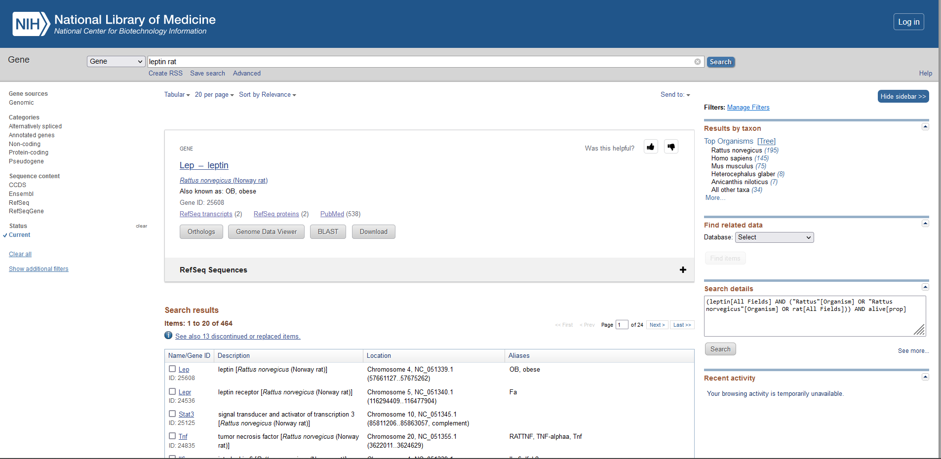

Chromosome location – Leptin Rat

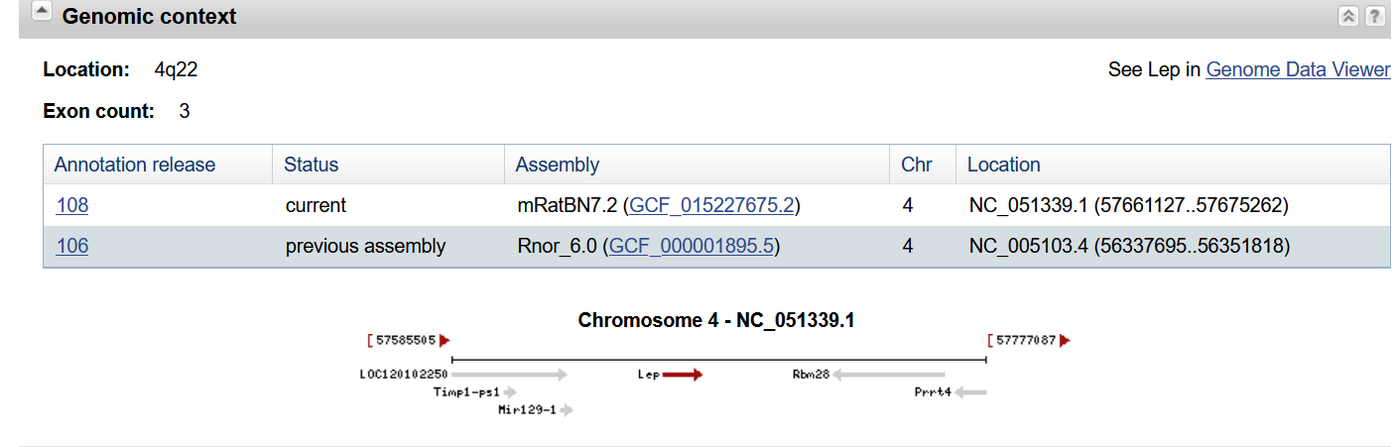

Genbank

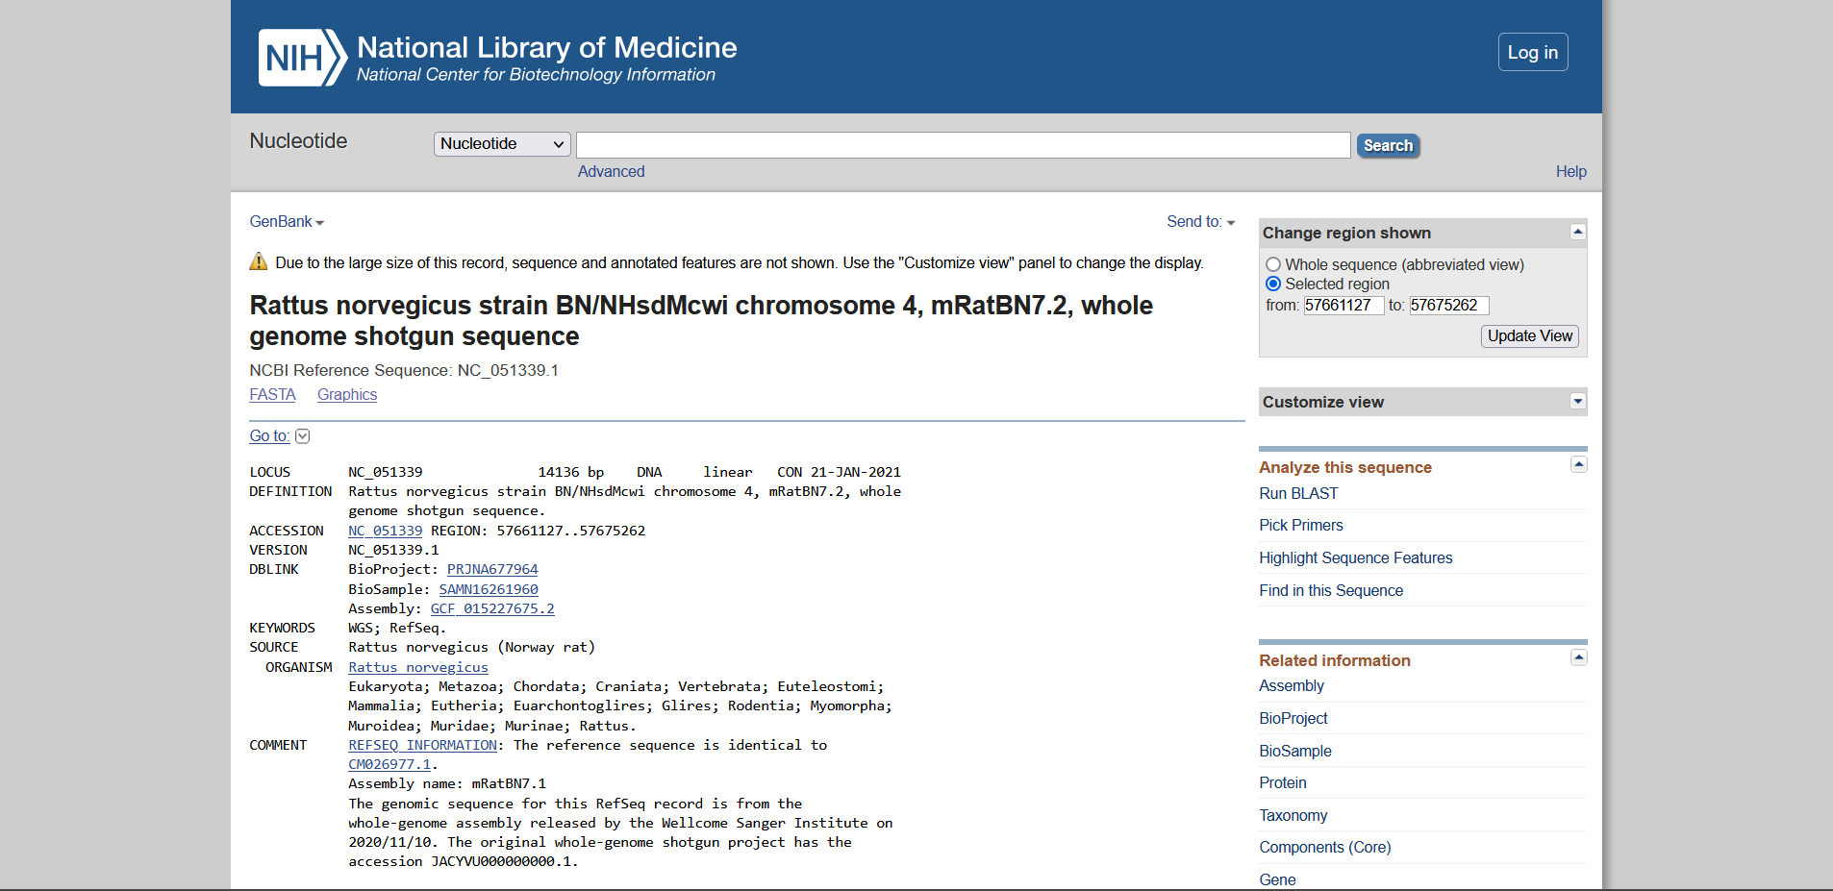

Gene Sequence – Leptin Rat

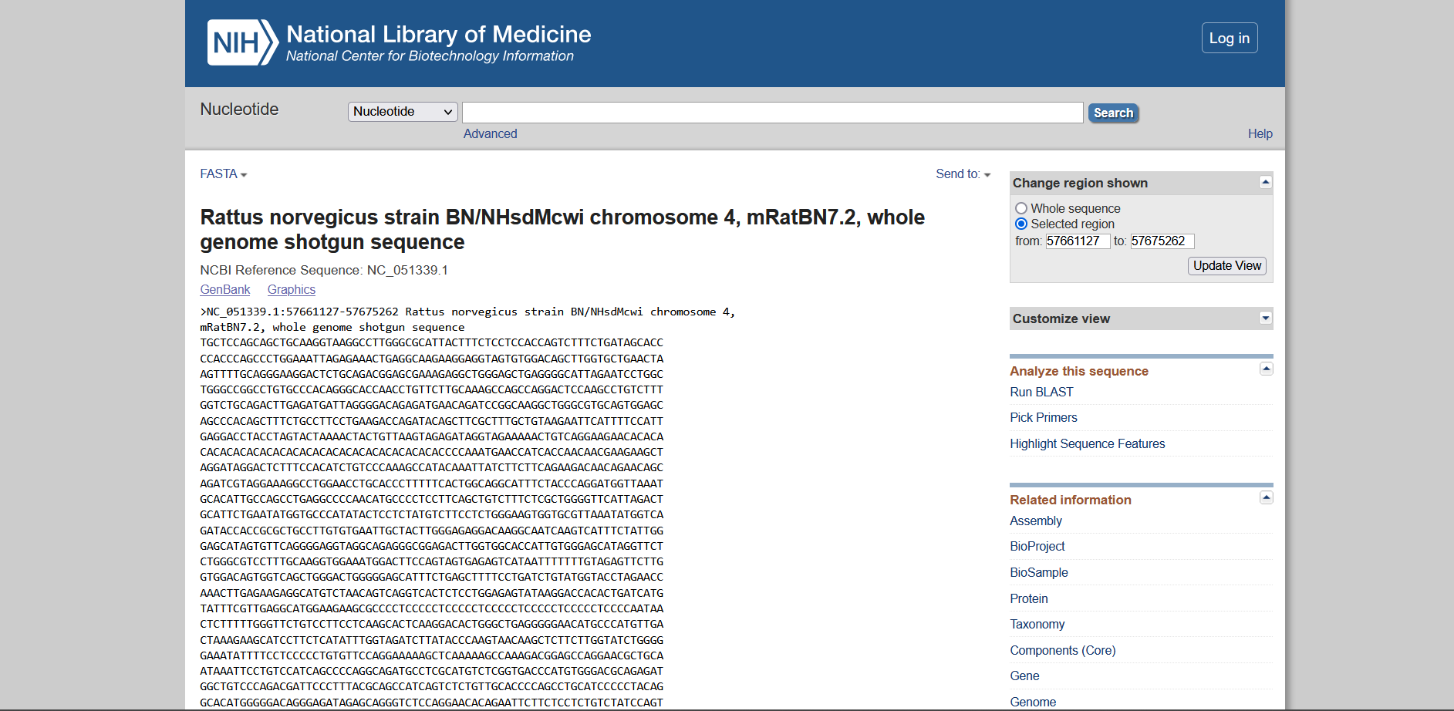

mRNA Sequence - Leptin Rat

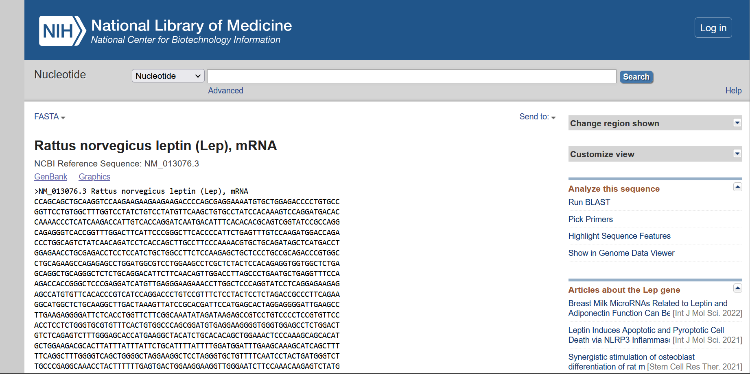

Chromosome location – Leptin receptor Rat

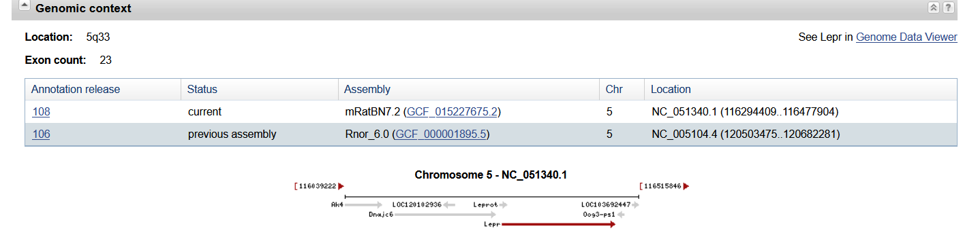

Genbank

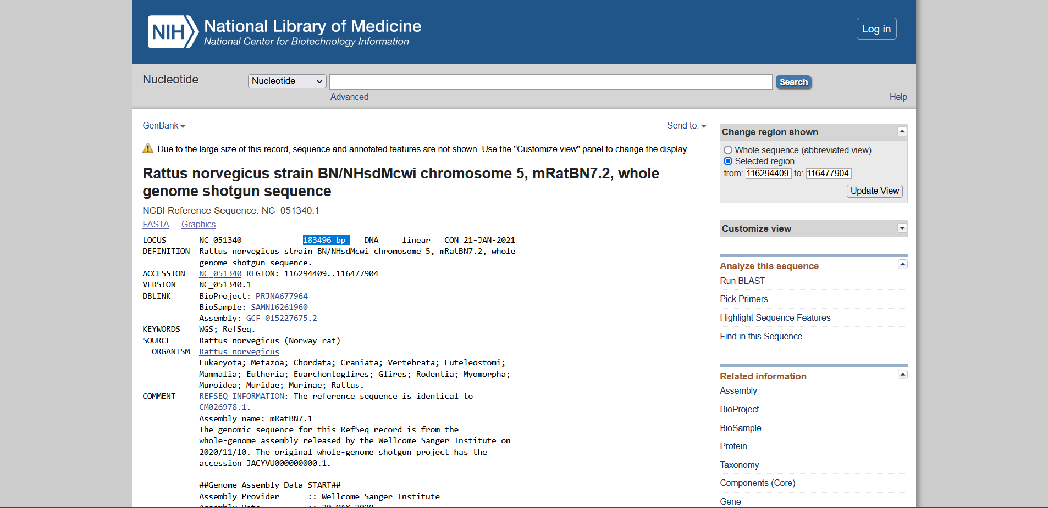

Gene Sequence – Leptin receptor Rat

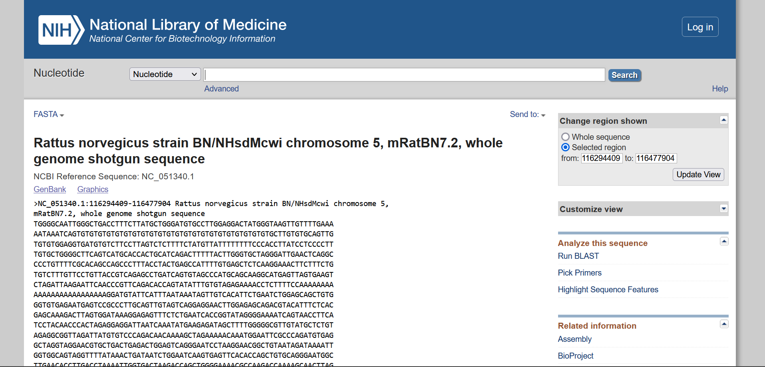

mRNA Sequence - Leptin receptor Rat

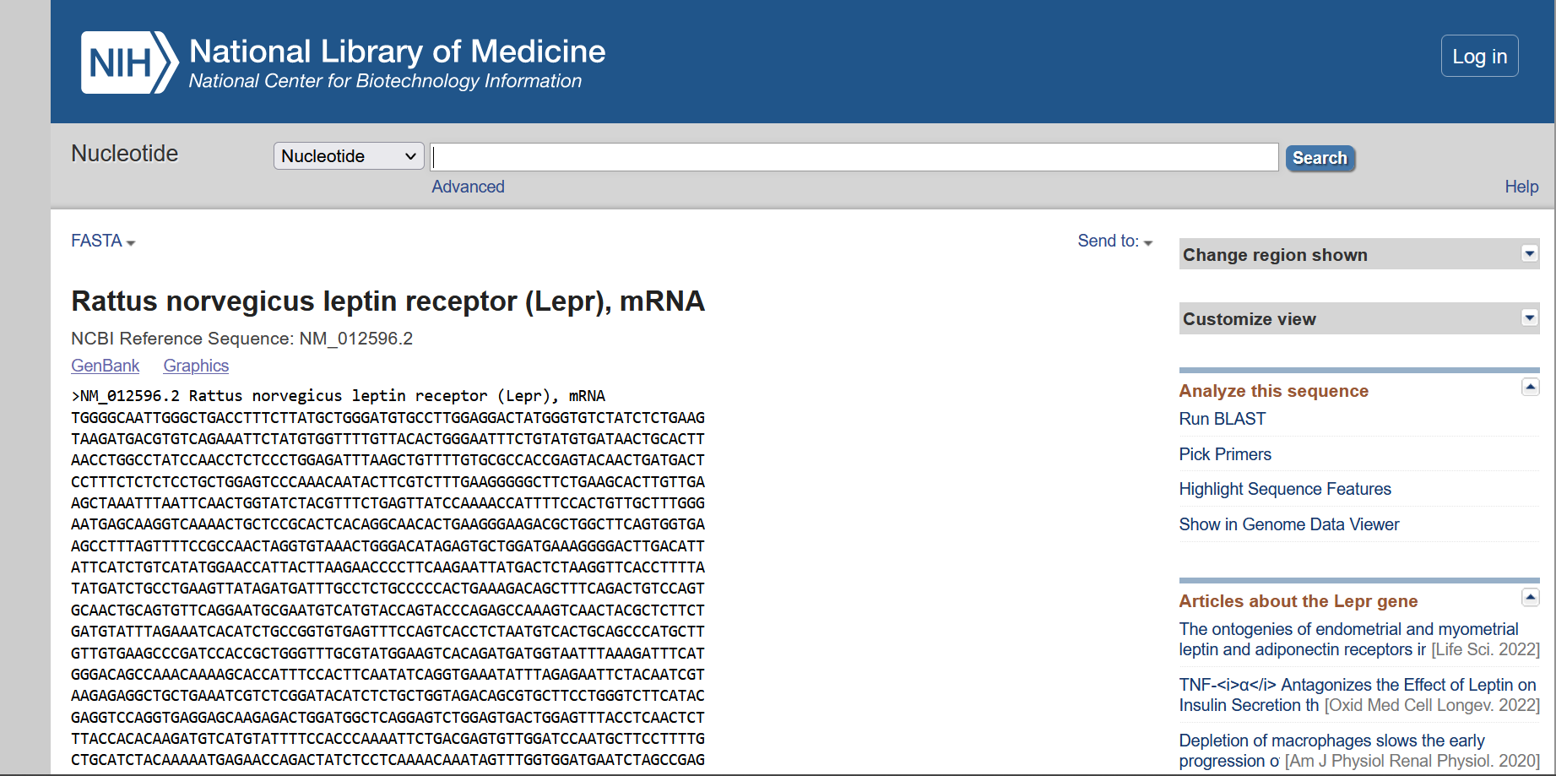

Organism: Cattle

|  |  |  |
| --- | --- | --- |
|  | Leptin | Leptin Receptor |
| Chromosomal Location | Chromosome 4  NC_037331.1 (92436837..92453660) | Chromosome 3  NC_037330.1 (79741204..79838014, complement) |
| Length of Gene Sequence | 16824 bp | 96811 bp |
| Accession Number | NC_037331 | NC_037330 |
| Number of Exons | 3 | 21 |
| Start and End positions of Exons |  |  |
| Publications |  |  |

Hits Page

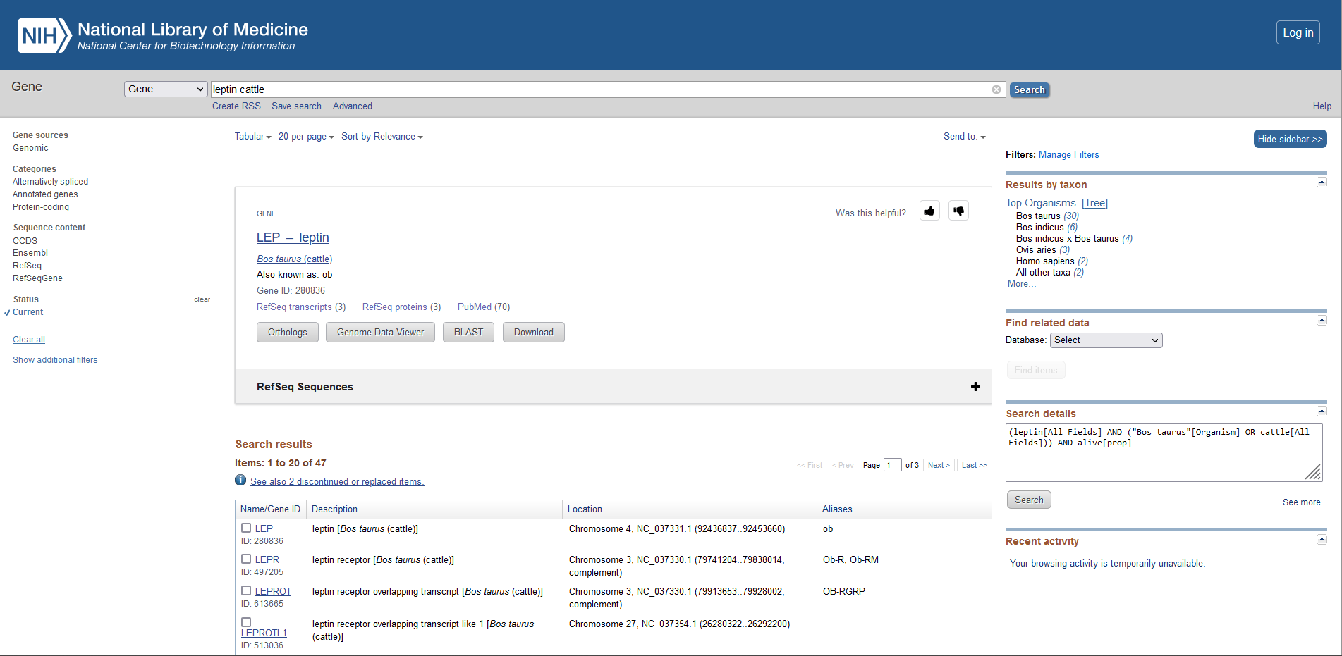

Chromosome location – Leptin cattle

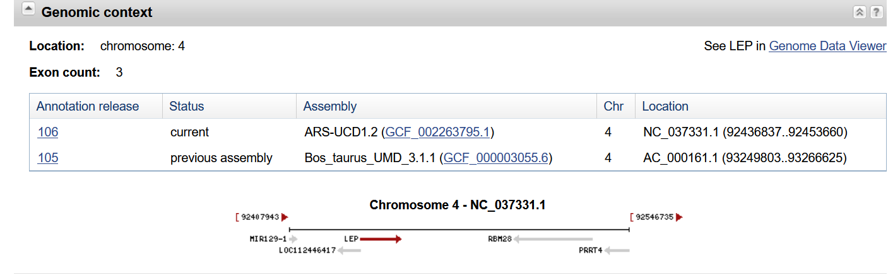

Genbank

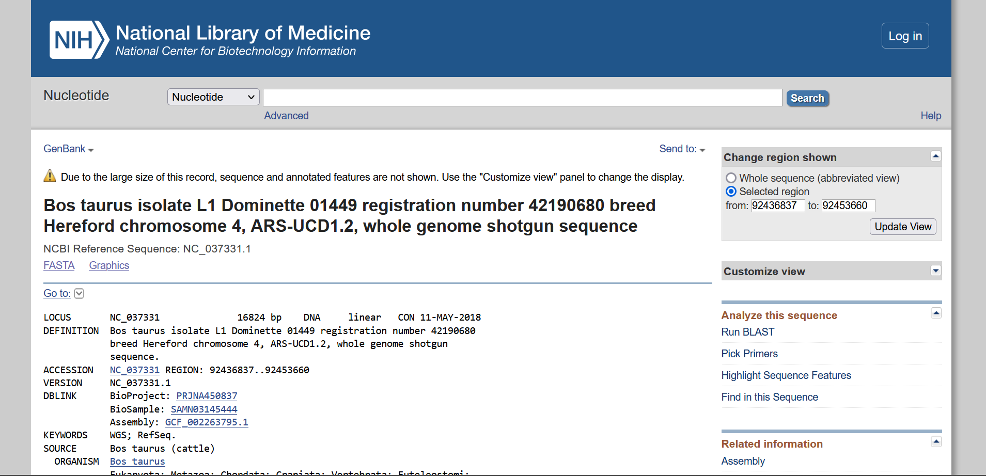

Gene Sequence – Leptin cattle

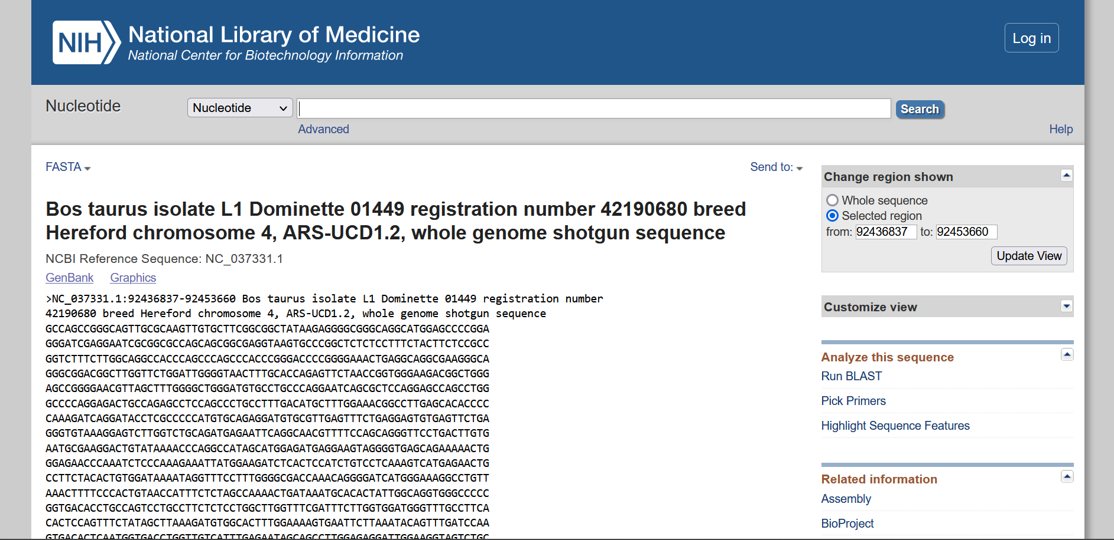

mRNA Sequence - Leptin cattle

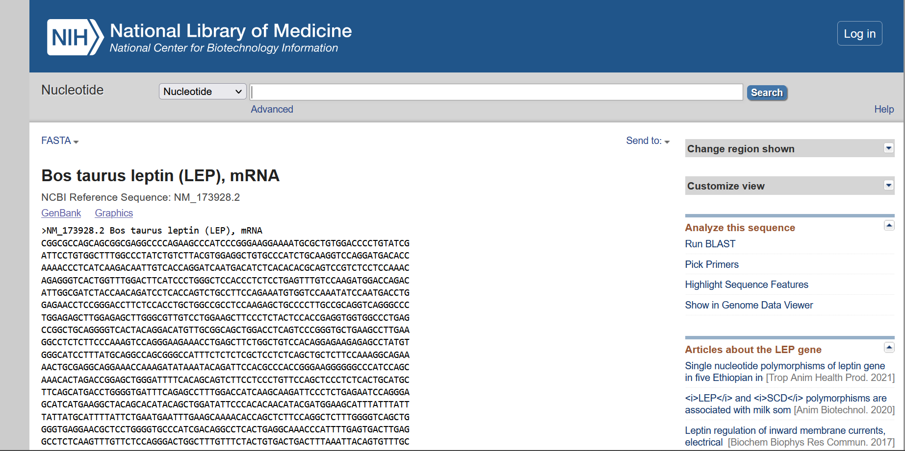

Chromosome location – Leptin receptor cattle

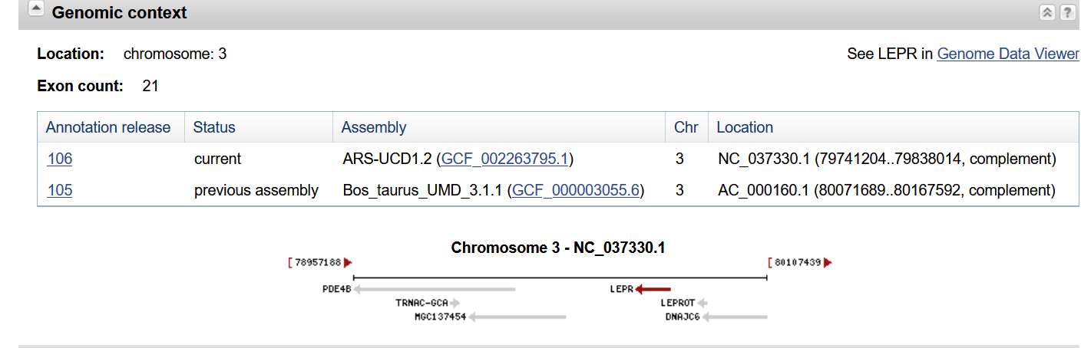

Genbank

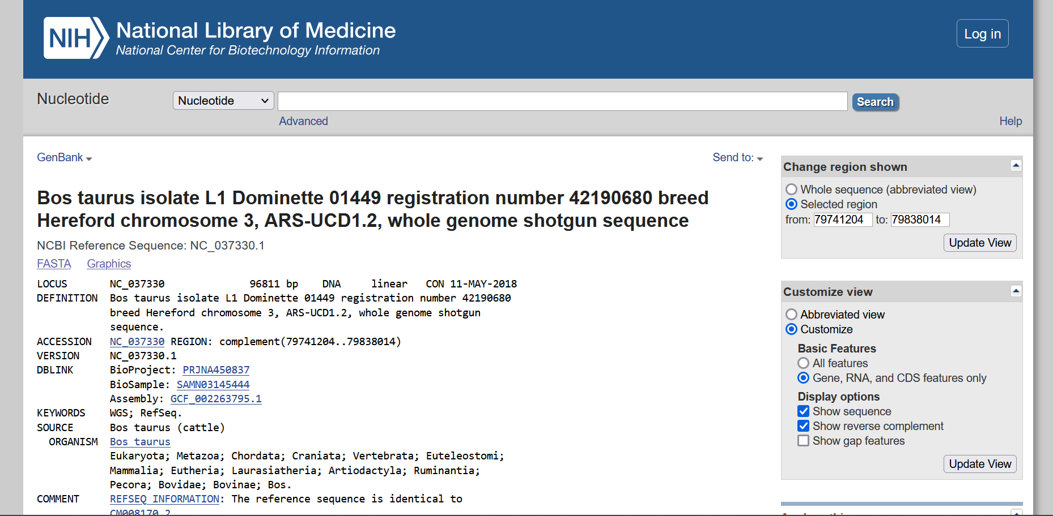

Gene Sequence – Leptin receptor cattle

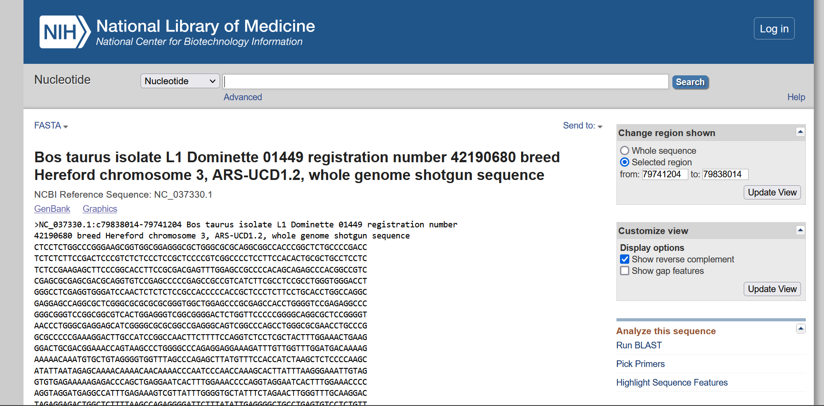

mRNA Sequence - Leptin receptor cattle

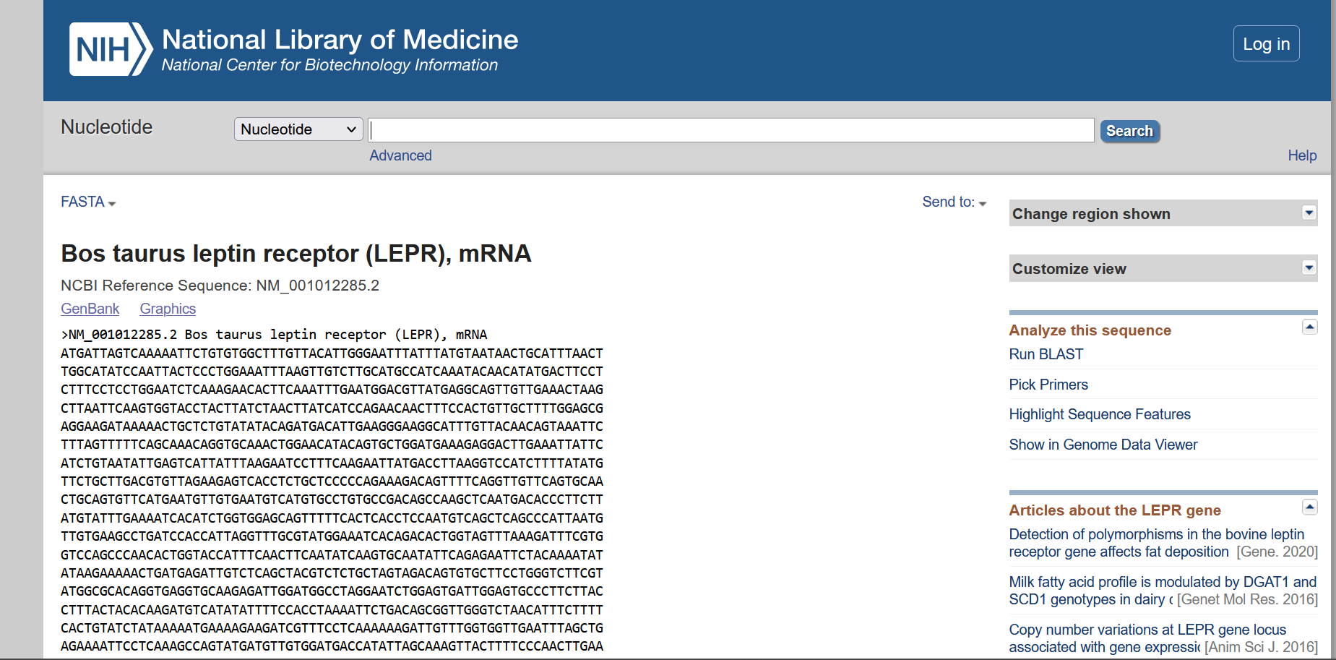

Organism: Pig

|  |  |  |
| --- | --- | --- |
|  | Leptin | Leptin Receptor |
| Chromosomal Location | Chromosome 18  NC_010460.4 (20106867..20124071, complement) | Chromosome 6  NC_010448.4 (146802297..146896152, complement) |
| Length of Gene Sequence | 17205 bp | 93856 bp |
| Accession Number | NC_010460 | NC_010448 |
| Number of Exons | 5 | 22 |
| Start and End positions of Exons |  |  |
| Publications |  |  |

Hits Page

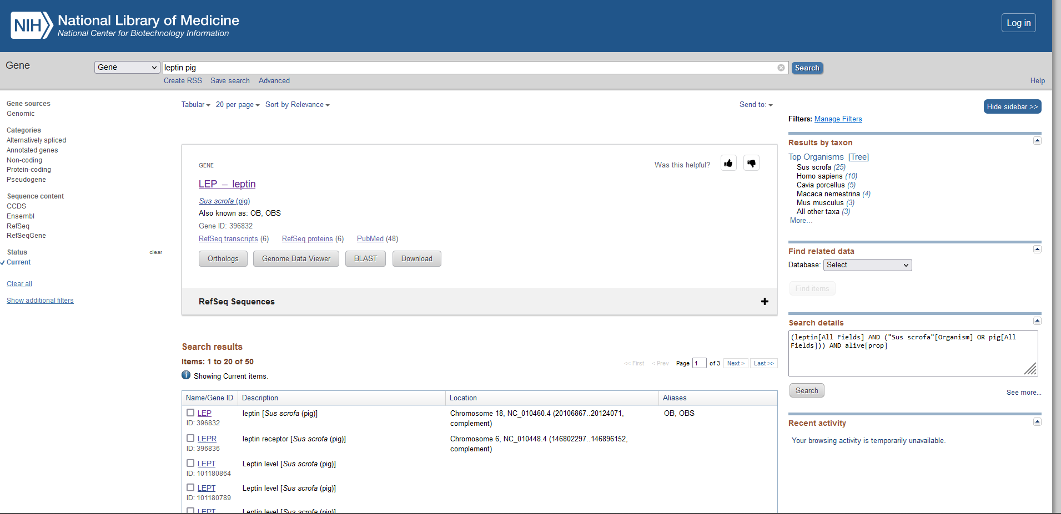

Chromosome location – Leptin Pig

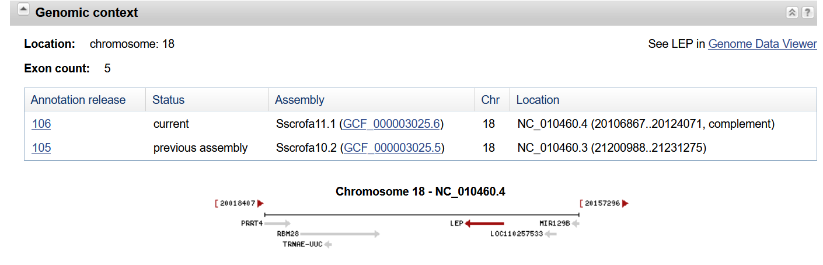

Genbank

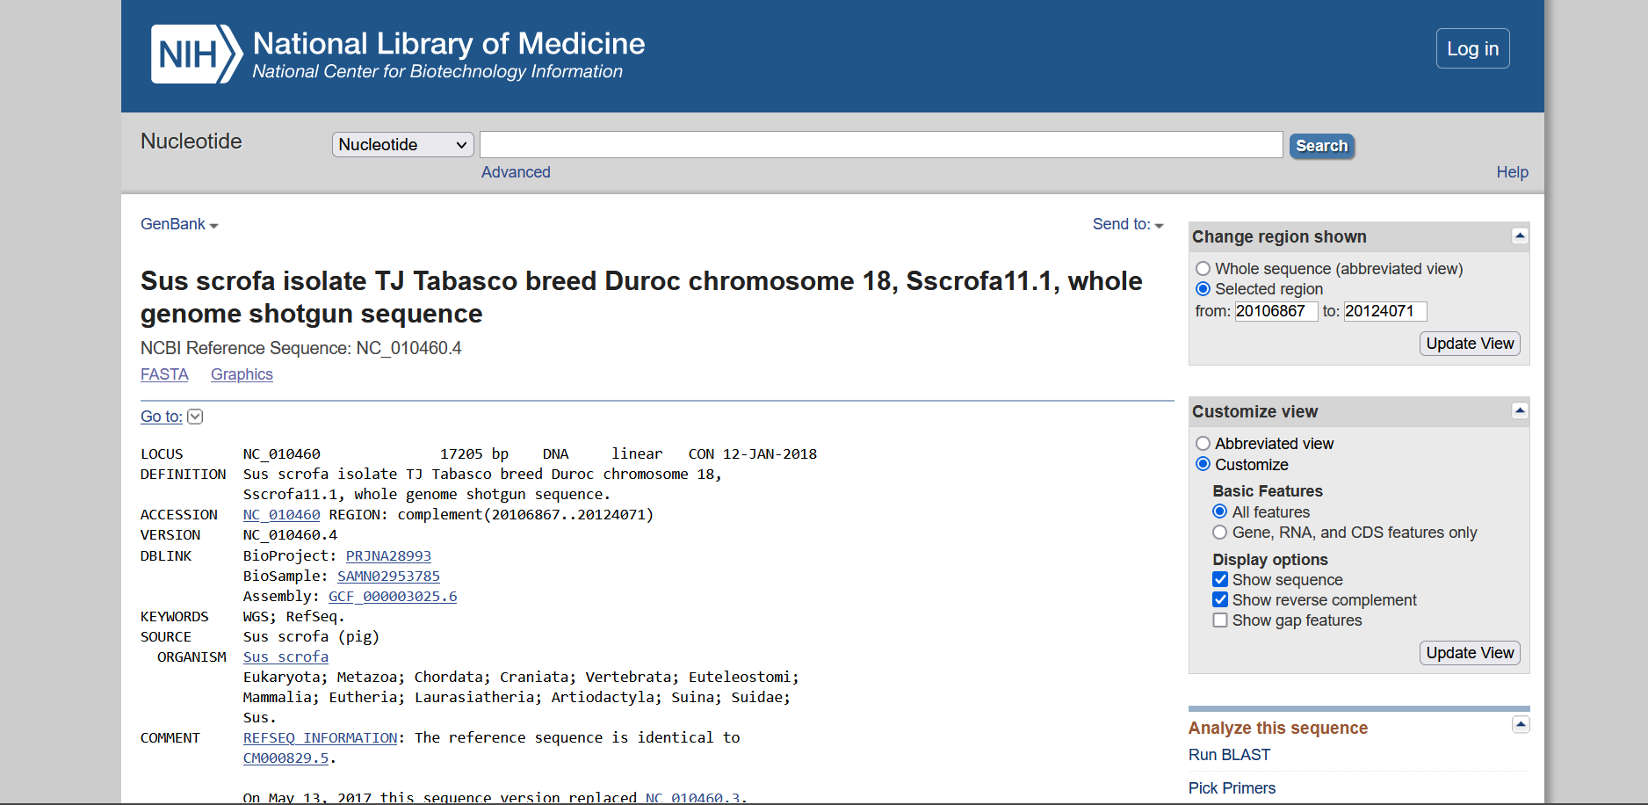

Gene Sequence – Leptin Pig

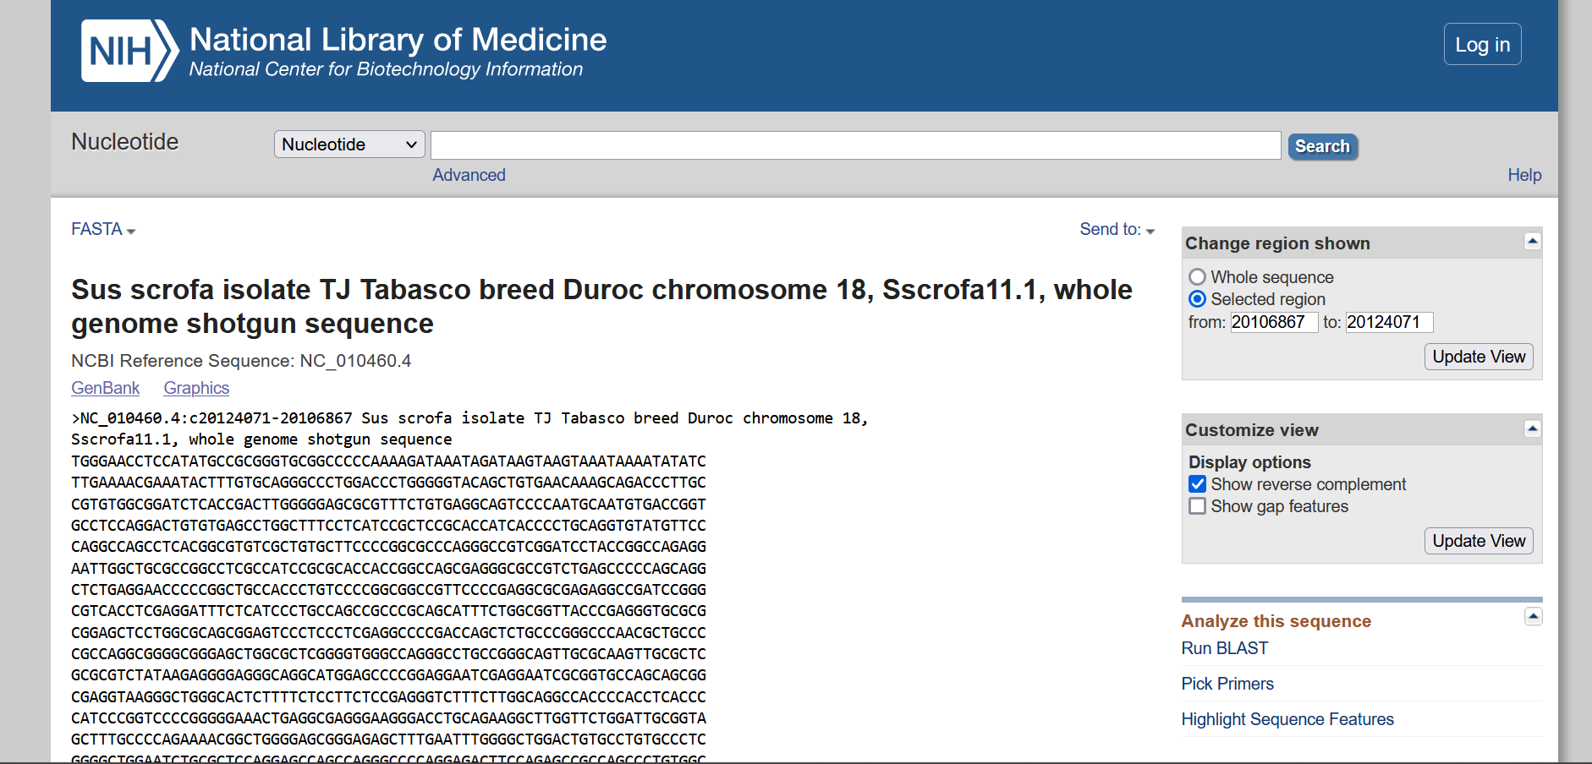

mRNA Sequence - Leptin Pig

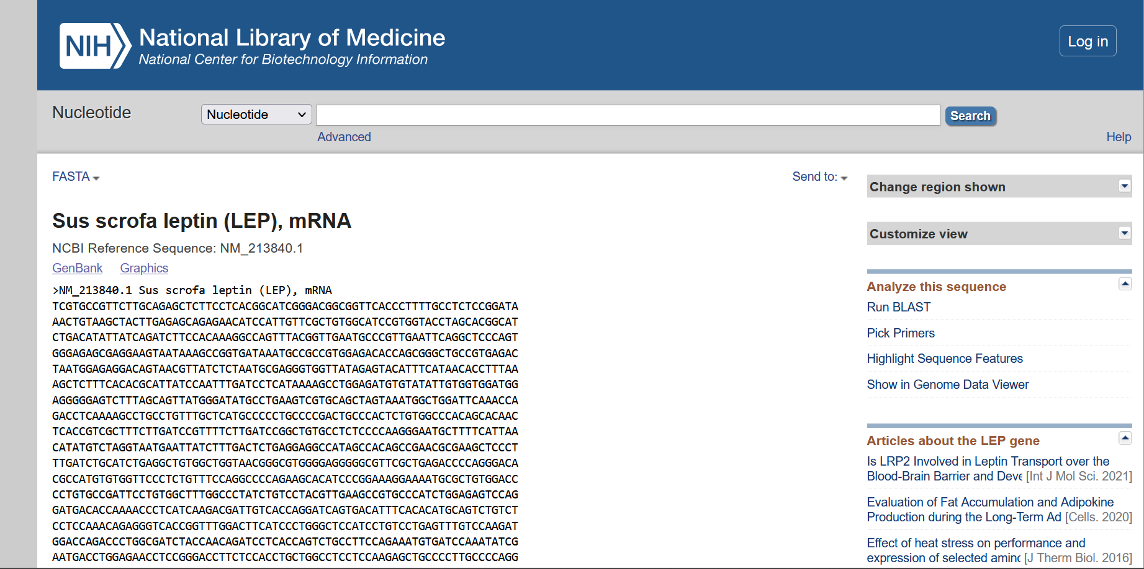

Chromosome location – Leptin receptor Pig

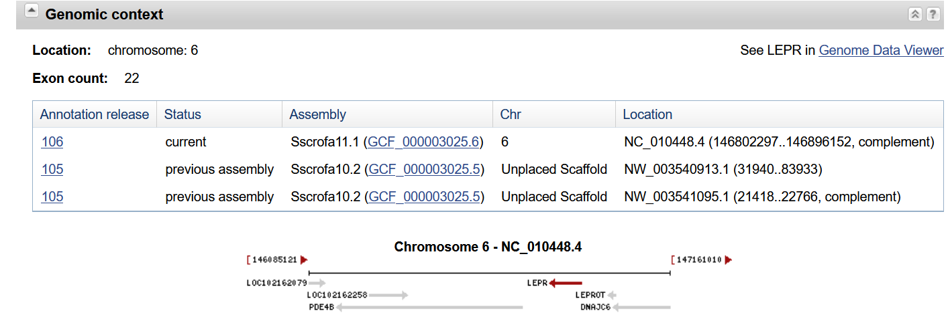

Genbank

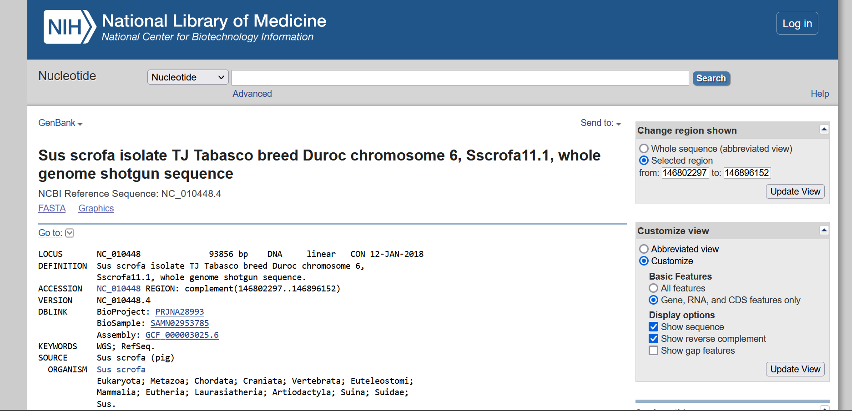

Gene Sequence – Leptin receptor Pig

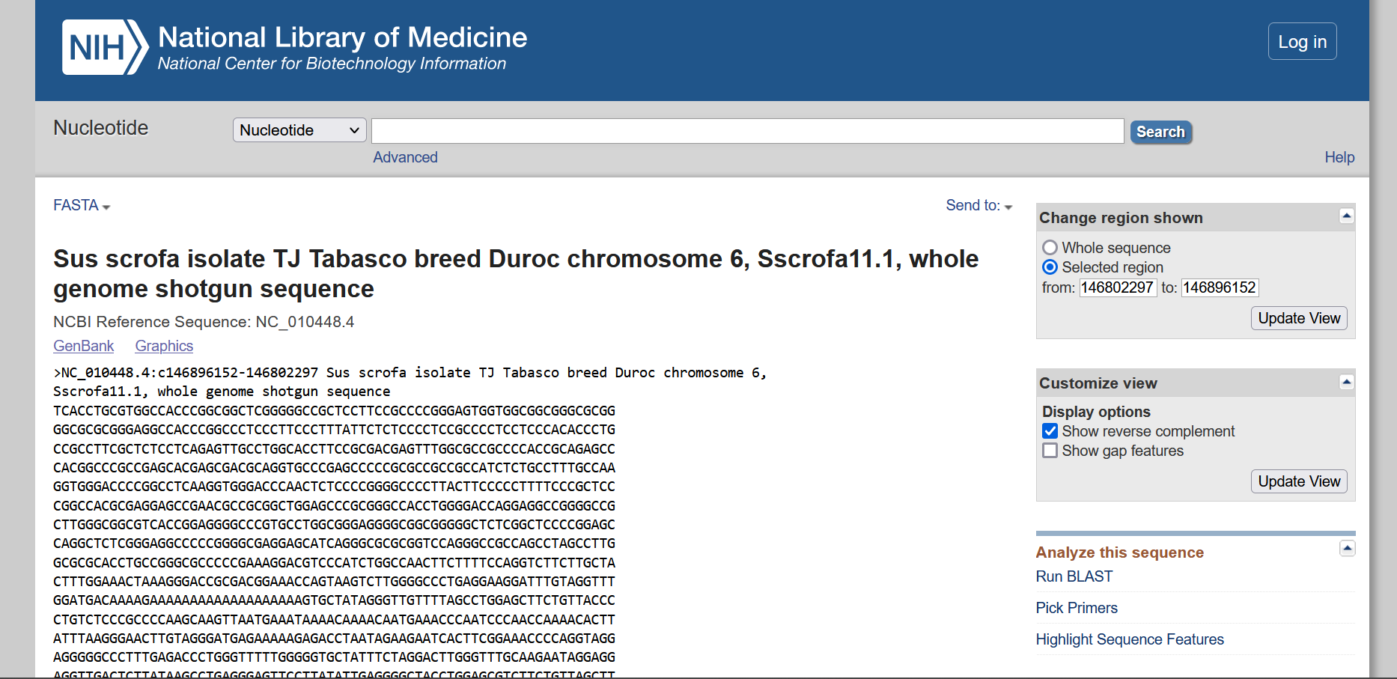

mRNA Sequence - Leptin receptor Pig

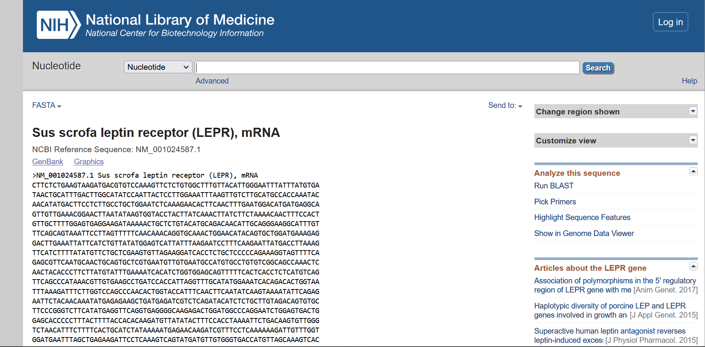

1. Retrieve the information of beta globin chain of Haemoglobin using the Uniprot ID P69892

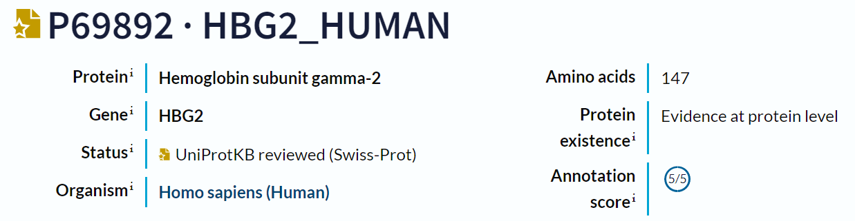

1. 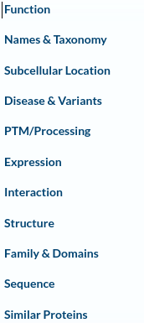Write down the contents of feature table.

The contents of the feature table are Functions, Names and taxonomy, Subcellular location, Disease and variant, PTM/processing, Expression, Interaction, Structure, Family and Domains, Sequence and Similar Proteins.

1. What are the molecular and biological function of the protein? Cite with one reference.

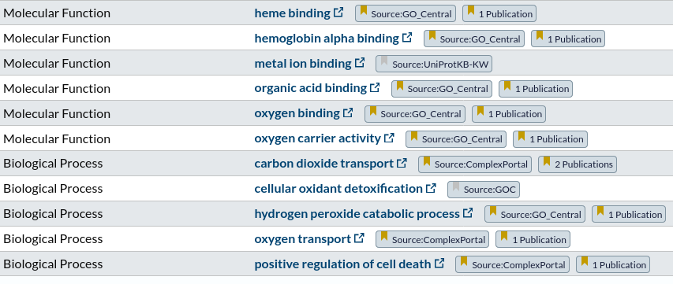 The molecular and biological function of the given protein with Uniprot ID P69892 are the follows, Molecular functions include Heme binding, Hemoglobin alpha binding, Metal ion binding, Organic acid binding, Oxygen binding and Oxygen carrier activity and the Biological functions include Carbon dioxide transport, Cellular oxidant detoxification, Hydrogen peroxide catabolic process, Oxygen transport, and Positive regulation of cell death.

The reference for the Oxygen transport and Heme binding function of the protein is given below

* Biological process - Oxygen transport

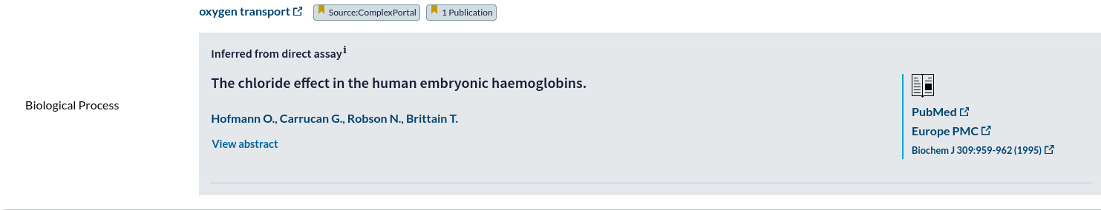

* Molecular functions - Heme binding

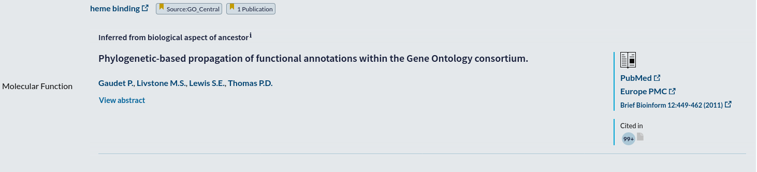

References

Gaudet, P., Livstone, M. S., Lewis, S. E., & Thomas, P. D. (2011). Phylogenetic-based propagation of functional annotations within the Gene Ontology consortium. *Briefings in bioinformatics*, *12*(5), 449-462.

1. What are the amino acid modification of these proteins?

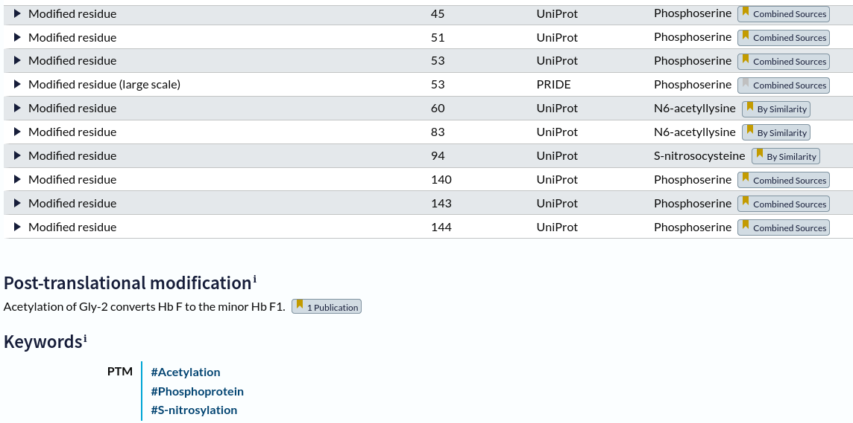 The major amino acid modification of the protein with Uniprot ID P69892 is

* Acetylation
* 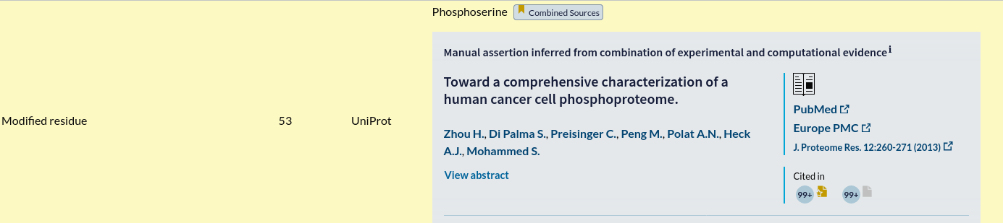Phosphoprotein
* S- nitrosylation

1. How many binary interactions of these proteins are found?

P69892 has binary interactions with 4 proteins

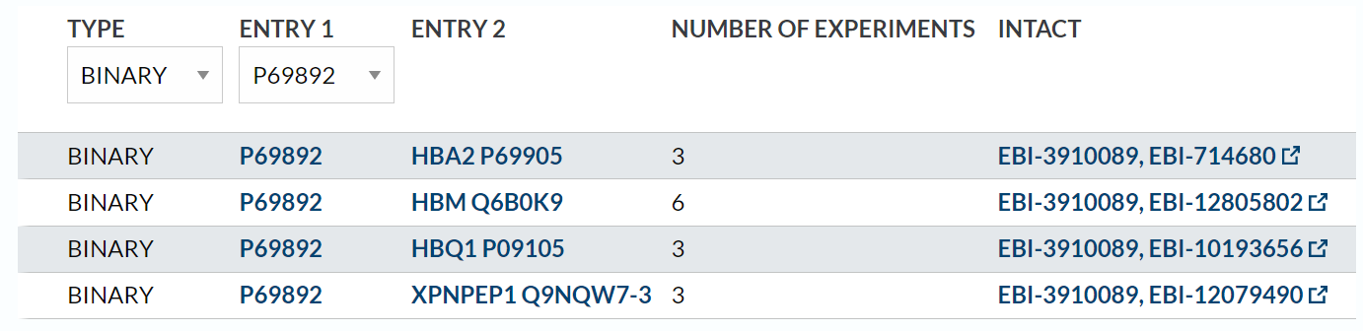

1. How many protein structures are found and their PDB ID?

There are 3 different protein structure with the PDB ID are given below

* 1FDH-Structure of Human Foetal Deoxyhaemoglobin
* 4MQJ-Structure of Wild-type Fetal Human Hemoglobin HbF
* 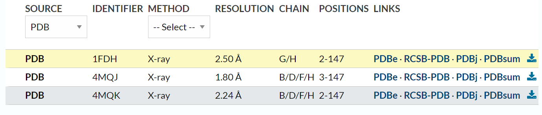4MQK-Carbonmonoxy Structure of the Human Fetal Hemoglobin Mutant HbF Toms River alphawtgammaV67M

1. How many isoforms of protein are there?

There are 8 isoforms of protein is listed below

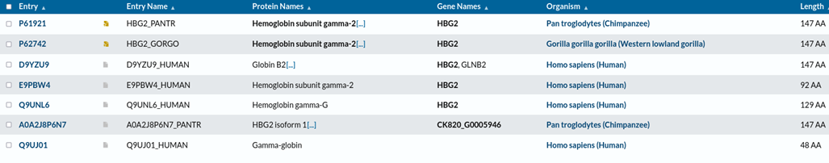

1. What is the length of the amino acid composition?

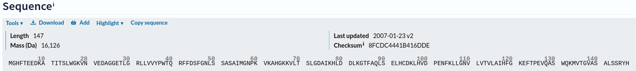The length of the amino acid composition is 147.

1. What are the structural differences of these proteins with references?

* 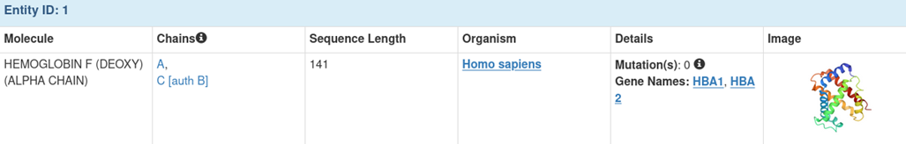1FDH-Structure of Human Foetal Deoxyhaemoglobin

References

Frier, J. A., & Perutz, M. F. (1977). Structure of human foetal deoxyhaemoglobin. *Journal of molecular biology*, *112*(1), 97-112.

* 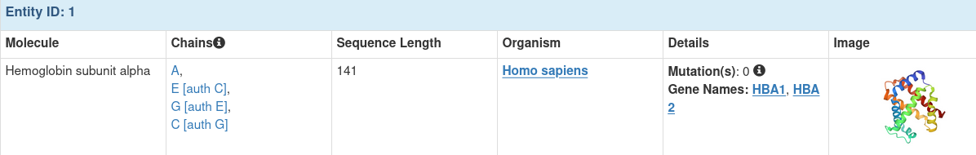4MQJ-Structure of Wild-type Fetal Human Hemoglobin HbF9.

References

Soman, J., & Olson, J. S. (2013). Structure of Wild-type Fetal Human Hemoglobin HbF.

* 4MQK-Carbonmonoxy Structure of the Human Fetal Hemoglobin Mutant HbF Toms River alphawtgammaV67M

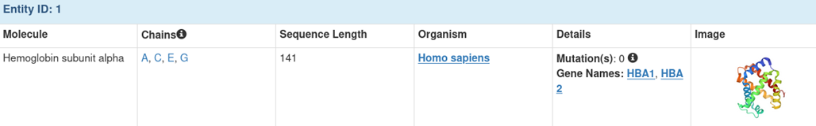References

Carbonmonoxy Structure of the Human Fetal Hemoglobin Mutant HbF Toms River alphawtgammaV67M Soman, J., Olson, J.S.

1. What is the chromosome location of Beta globulin chain?

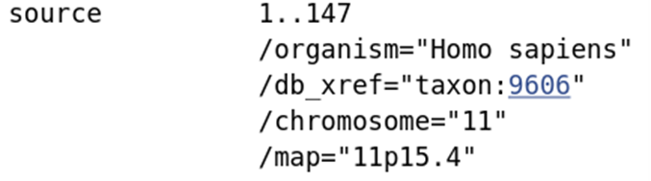The Beta globulin chain is located on the 15th region in the p- arm or short arm of chromosome 11.



1. Find the experimental annotation of the protein?

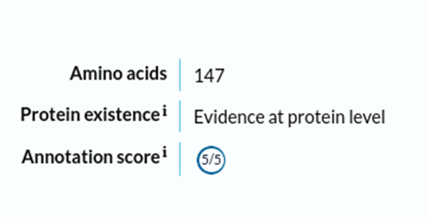The experimental annotation of the protein is 5 out of 5.

Retrieve the information using the database PDB by searching the keyword Human

Haemoglobin

1. How many structures are deposited in the PDB for Human Haemoglobin?



83056 structures are deposited

2. Write down any 5 PDB ID of the human haemoglobin and cite their references?

1. 1HDA

Perutz, M. F., Fermi, G., Poyart, C., Pagnier, J., & Kister, J. (1993). A novel allosteric mechanism in haemoglobin: structure of bovine deoxyhaemoglobin, absence of specific chloride-binding sites and origin of the chloride-linked Bohr effect in bovine and human haemoglobin. *Journal of molecular biology*, *233*(3), 536-545.

2. 5EE2

Wong, C. T., Xu, Y., Gupta, A., Garnett, J. A., Matthews, S. J., & Hare, S. A. (2015). Structural analysis of haemoglobin binding by HpuA from the Neisseriaceae family. *Nature communications*, *6*(1), 10172.

3. 5JDO

Lane-Serff, H., MacGregor, P., Peacock, L., Macleod, O. J., Kay, C., Gibson, W., ... & Carrington, M. (2016). Evolutionary diversification of the trypanosome haptoglobin-haemoglobin receptor from an ancestral haemoglobin receptor. *Elife*, *5*, e13044.

4. 4X0J

Lane-Serff, H., MacGregor, P., Lowe, E. D., Carrington, M., & Higgins, M. K. (2014). Structural basis for ligand and innate immunity factor uptake by the trypanosome haptoglobin-haemoglobin receptor. *Elife*, *3*, e05553.

5. 1C40

Liu, X. Z., Li, S. L., Jing, H., Liang, Y. H., Hua, Z. Q., & Lu, G. Y. (2001). Avian haemoglobins and structural basis of high affinity for oxygen: structure of bar-headed goose aquomet haemoglobin. *Acta Crystallographica Section D: Biological Crystallography*, *57*(6), 775-783.

3. How many citations are there in the PDB associated with human Haemoglobin protein structure?

4. Write down the structural properties of the haemoglobin with PDB ID: 1HAB

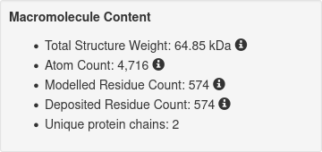

Total Structure Weight: 64.85 kDa

1. Atom Count: 4,716
2. Modelled Residue Count: 574
3. Deposited Residue Count: 574
4. Unique protein chains: 2

(a) Experimental methods

The experimental method : X-RAY DIFFRACTION

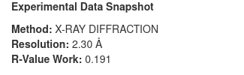

(b) Date of submission

It was deposited on 1996-03-13 and released on 1997-11-12



(c) Resolution of the protein structure

Resolution of the protein structure is 2.30 A



(d) PubMed ID

The PubMed ID is 9223274

  
(e) Total structure weight

The structural weight is 64.85 kDa



(f) Protein chains

Hemoglobin A has 4 protein chains A , B , C and D

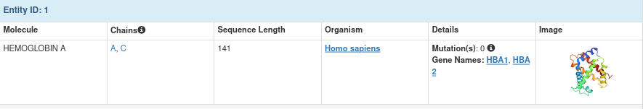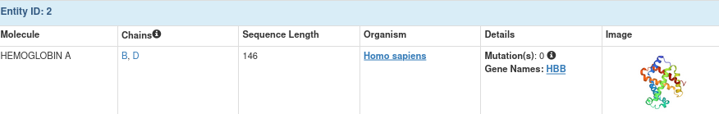

(f) Sequence length

 Sequence length is 141 and 146



(g)Organism

The organism is Homo Sapiens

(h) Ligands bounded to proteins

(I) References

8. What are the structural differences of these proteins with references?

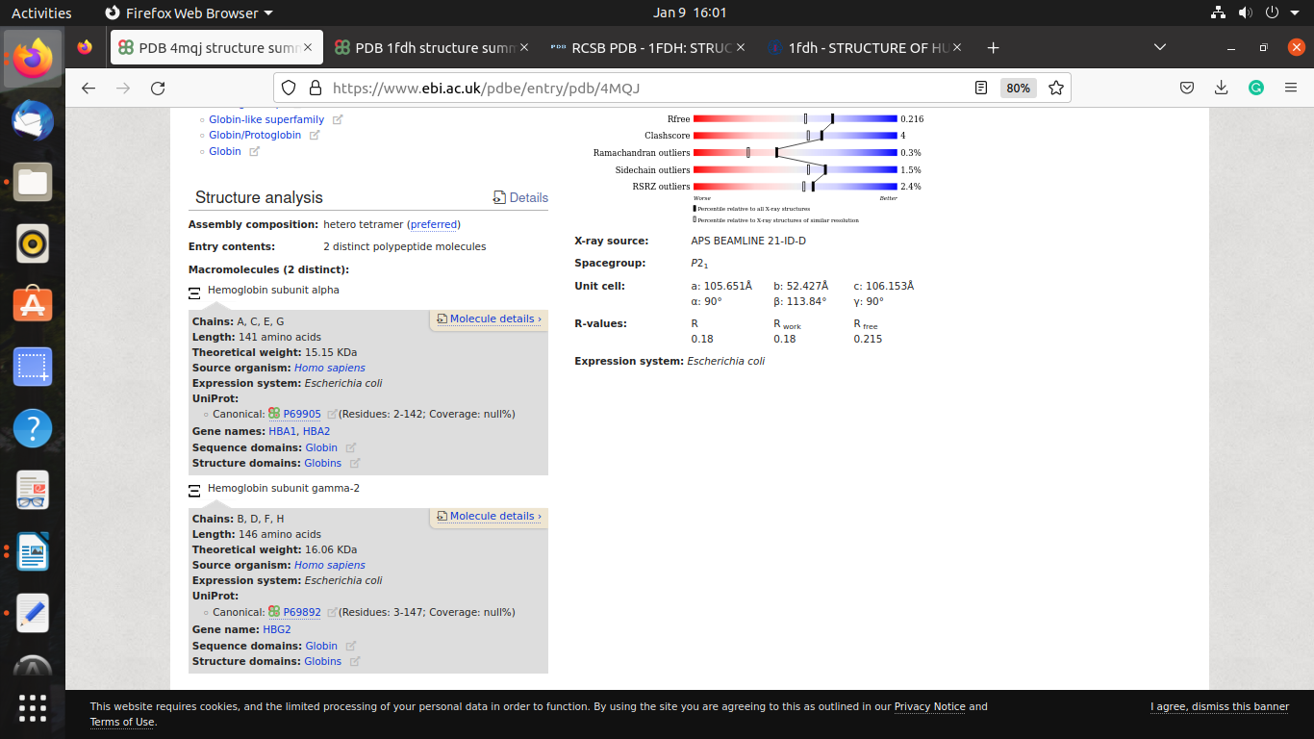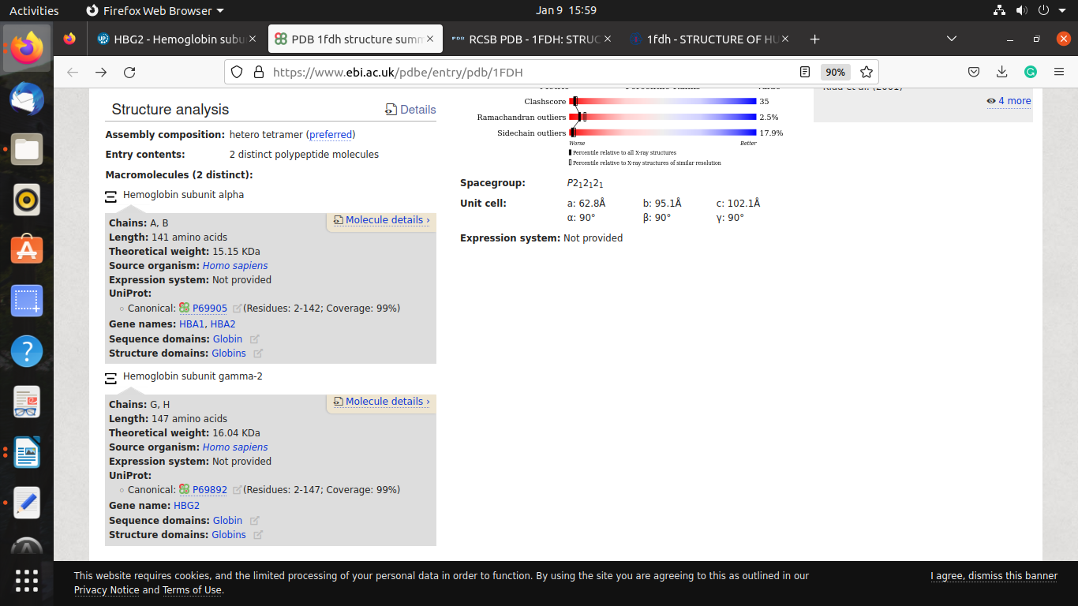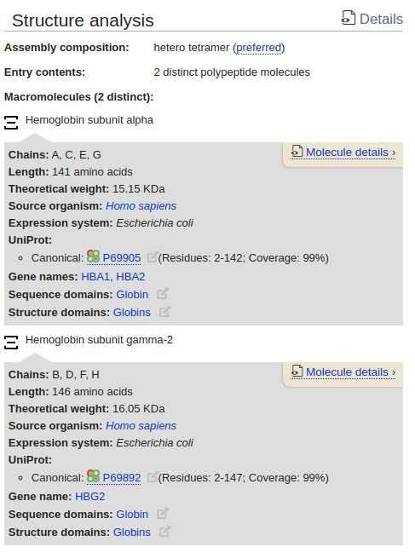

9. What is the chromosome location of Beta globulin chain?

10. Find the experimental annotation of the protein?

